Code4Kids Summer Coding Academy 2018
Leader Guide

Table of Contents

Day 1 (Monday) 2
Supplies 2
Goals for Day 1 (Monday) 2
Schedule for Day 1 (Monday) 3
Lightbot Level 1 6
Evo Obstacle Course 10

Day 2 (Tuesday) 11
Supplies 11
Goals for Day 2 (Tuesday) 11
Schedule for Day 2 (Tuesday) 12

Lightbot Level 2 21

Day 3 (Wednesday) 26
Supplies 26
Goals for Day 3 (Wednesday) 26
Schedule for Day 3 (Wednesday) 27
Evo Obstacle Course with Blockly 28
Sample Solution (Mode 2) 28
Fashion Runway 29
Dance Lesson 29
Loop #1: Square Forever (Mode 2) 30
Extra Credit: 4 Blocks (Mode 2) 30
Loop #2: Square With Spin (Mode 2) 31
Extra Credit: 7 blocks (Mode 2) 31

Slot Car Racing Course 32
Instructions (Level 1) 32
Instructions (Level 2) 32
Slot Car Level 2 Solution 33

Ozoblockly Editor 34

Day 4 (Thursday) 35
Supplies 35
Goals for Day 4 (Thursday) 35
Schedule for Day 4 (Thursday) 35
Driver’s Ed: Wavy Way 36
Drivers Ed: Wavy Way Solution 37
Driver’s Ed: Traffic Trouble 38
Driver’s Ed: Traffic Trouble Solution 39
Driver’s Ed: Traffic Trouble – Cards 40

Day 1 (Monday)

Supplies
- Tablets for each kid  - Real Life Lightbot Supplies  - 10 white posterboard  - 2 blue posterboard  - 2 yellow posterboard  - 4 black posterboard (or leave those areas blank)  - Stacks of command cards: Forward, Right, Left, Jump, Light On | - Name tags  - Art supplies for decorating name tags  - Ozobot Evo’s  - DIY Packs/Skins for each kid  - Demo Supplies:  - Shapeoko CNC mill  - Laptop running Easel software to program the CNC mill. Have “Cody” loaded  - Name tag secured to the CNC mill bed  - Sharpie secured to CNC mill

Goals for Day 1 (Monday)
- Learn the basics of computer programming using the app “Lightbot”
- Learn how to control the robot (known as the “Ozobot Evo”) manually using the tablet

Schedule for Day 1 (Monday)
Start Time | Est. Time | Description
8:45 | 30 | Registration  Kids can start decorating their nametags [art, visual, tactile]
9:15 | 5 | Demo: CNC mill programmed with Cody’s name [inspiration, visual]
9:20 | 5 | Group sharing: “If I could make anything...” [imagination, social, auditory]
9:25 | 5 | Share plan for the week:  1. Learn to program in a game (Lightbot)  2. Control a robot with colors and lines (Ozobot Color Codes)  3. Control a robot with visual programming blocks (Ozoblockly)
9:30 | 10 | Real Life Lightbot 1-1 (immediate mode) – p.3 [social, tactile, visual, code]
9:40 | 10 | Real Life Lightbot 1-2 (program mode) [social, tactile, visual, code]
9:50 | 10 | Real Life Lightbot 1-3 (jumping) [social, tactile, visual, code]
10:00 | 30 | Snack  Make a “robot” with your snack food [social, food, tactile, art, visual]  * Most creative snack badge
10:30 | 10 | Hand out tablets and show how to work with Fully Kiosk Browser app (swipe to switch, etc)  Each kid gets the same tablet for the whole week
10:40 | 30 | Launch Lightbot on tablet and do all of the challenges in Level 1 [screen, code]  * Lightbot 1 badge for all  Leaders: setup Evo Obstacle Course while kids do Lightbot  Leaders: help kids when they’re stuck with a level, but try to talk them through it rather than giving them the answer
11:10 | 5 | Demo: Evo Manual Control (drive, sounds, colors, color animations) [social, visual]
11:15 | 10 | Pass out Evo that is already paired with each tablet  Each kid gets the same Evo for the whole week (and takes it home at the end)  Make sure everyone can launch the Evo app, connect, and start driving
11:25 | 30 | Evo Obstacle Course Races [screen, tactile, competition]  ++ With extra time, decorate your Evo with the DIY pack stickers and skins  * Gold, Silver, Bronze badges for the top three  * Evo Driver badge for all
12:00 |  | GO HOME
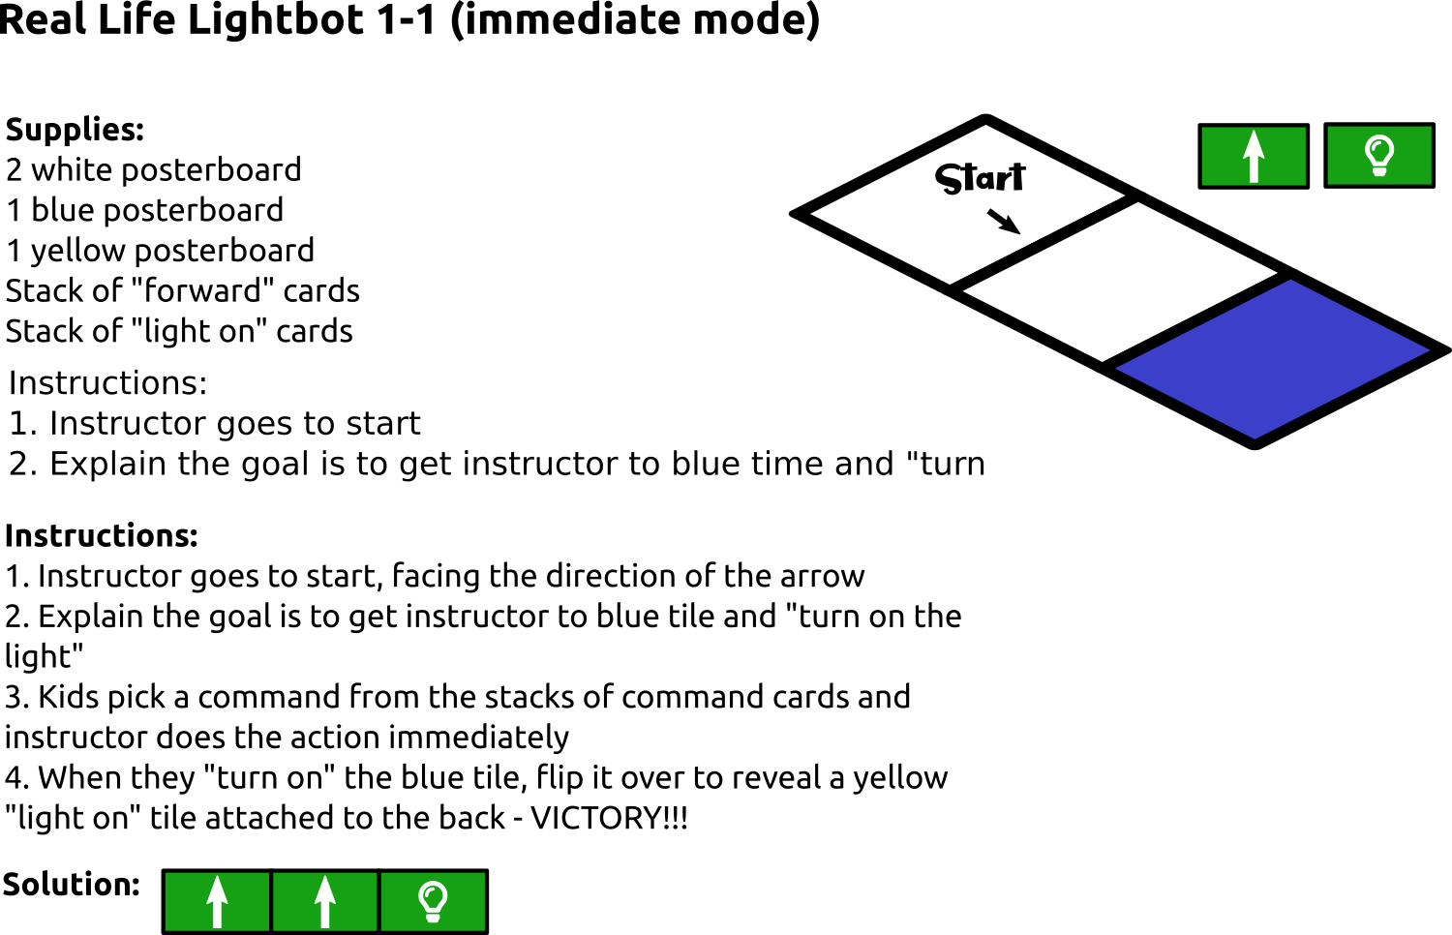
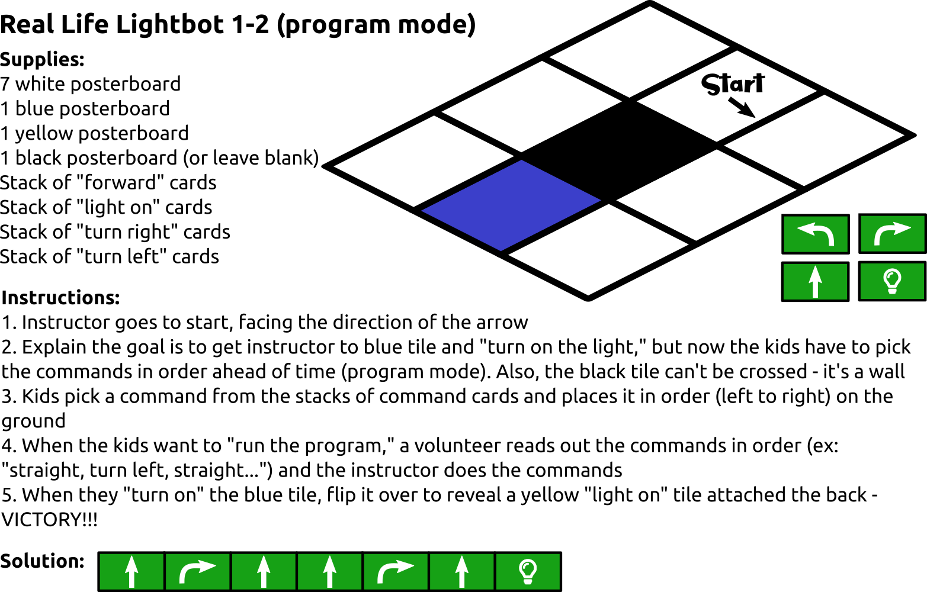

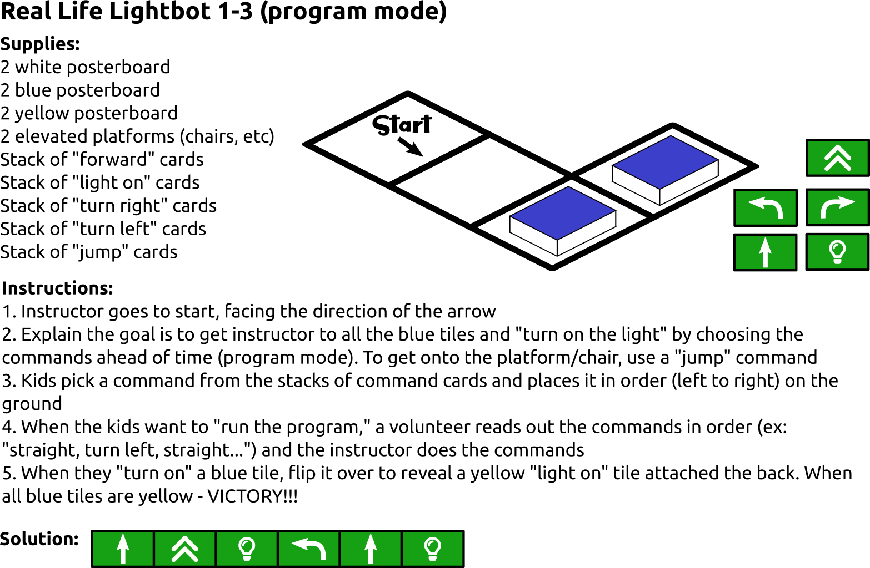

Lightbot Level 1
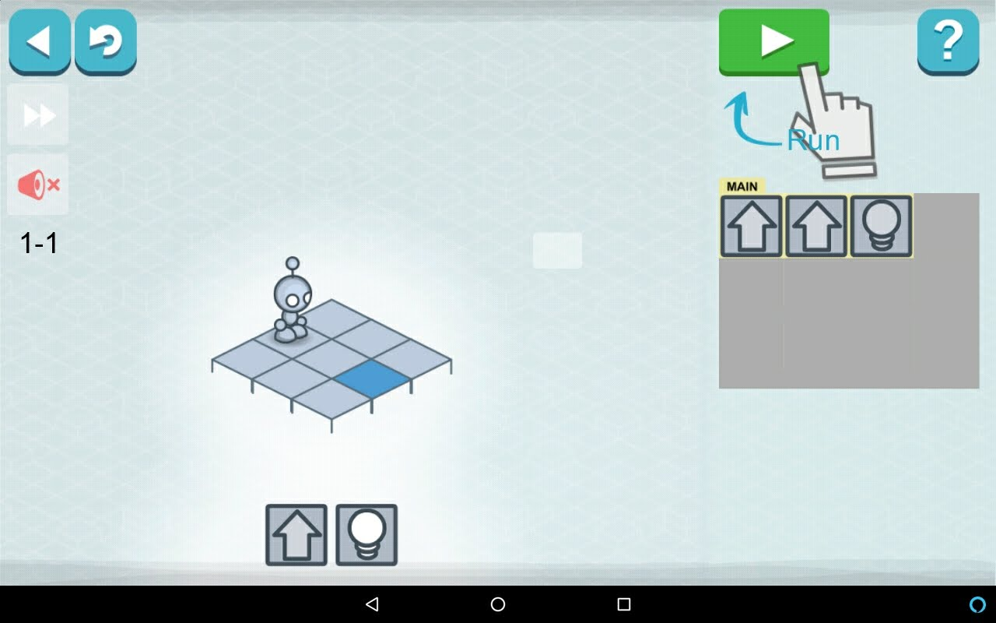
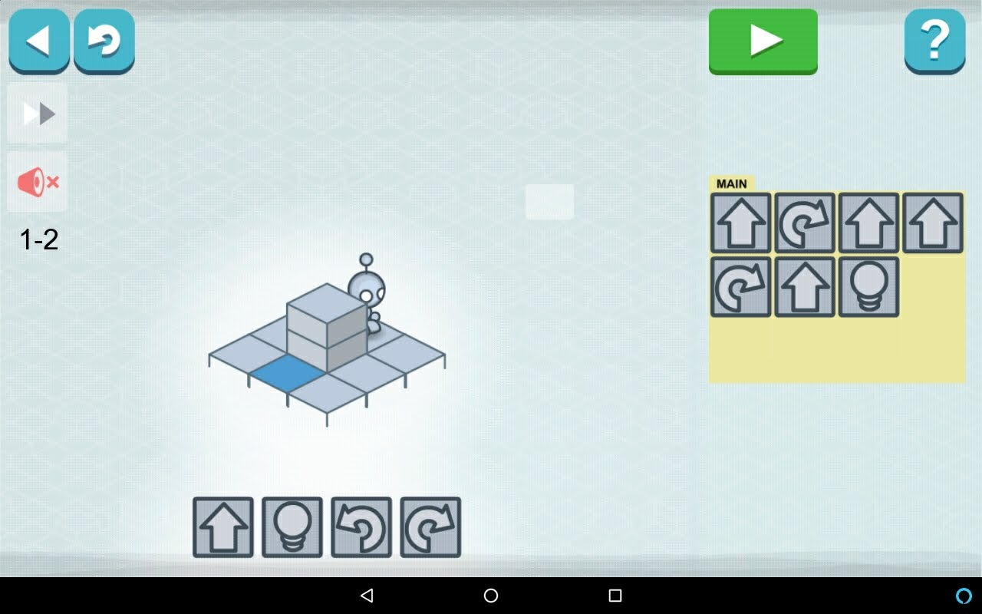
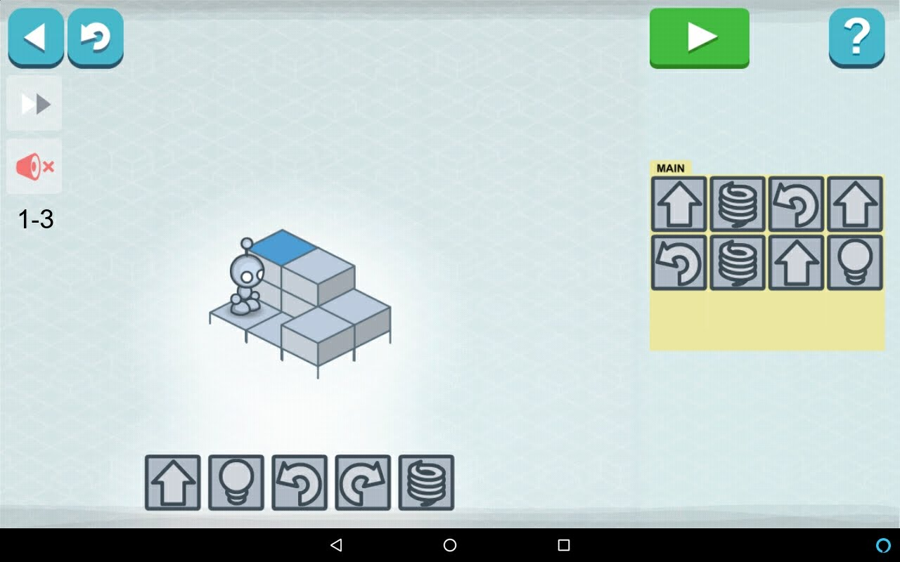
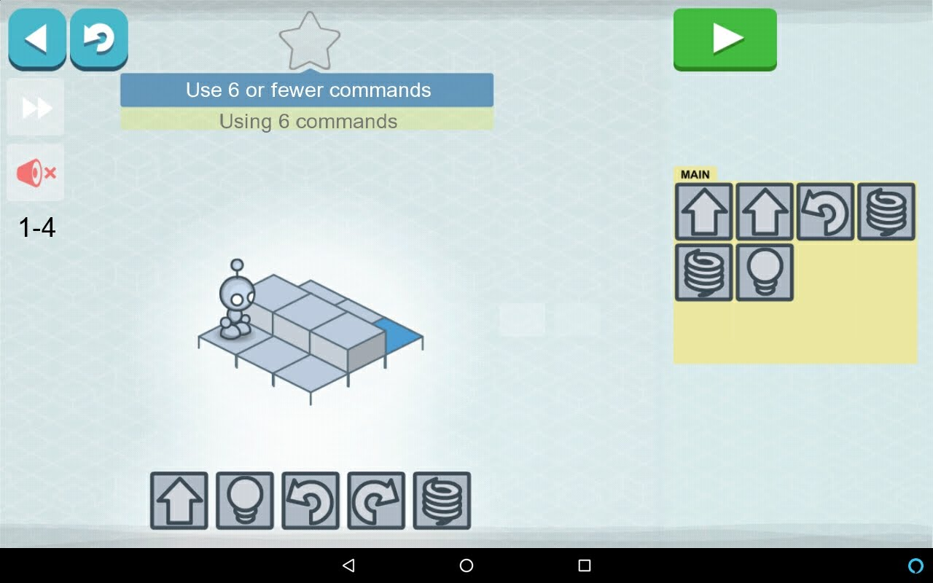
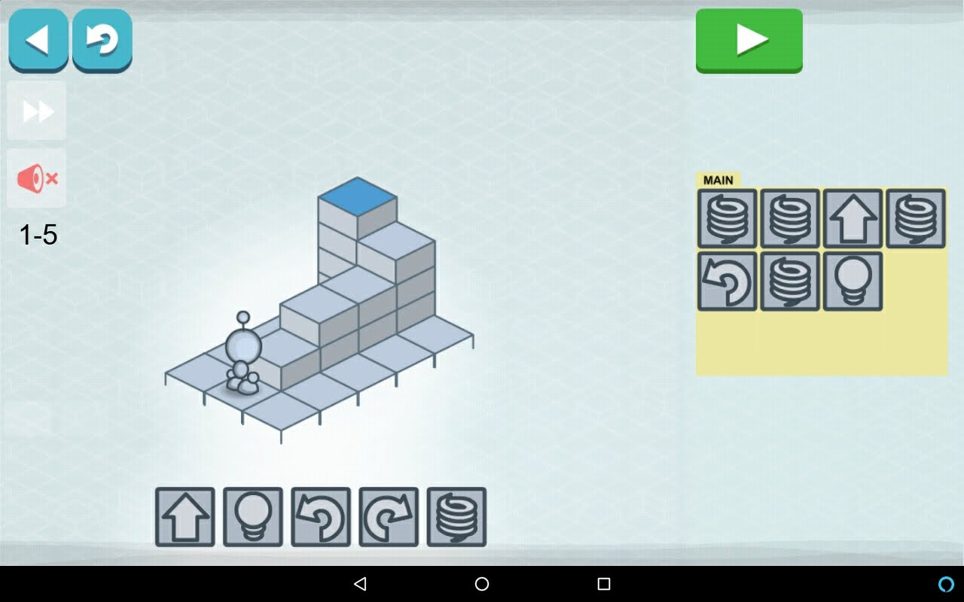
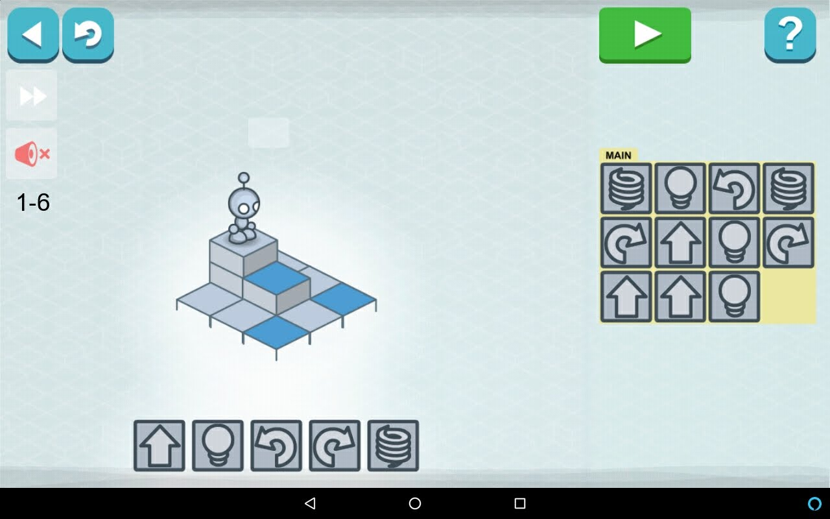
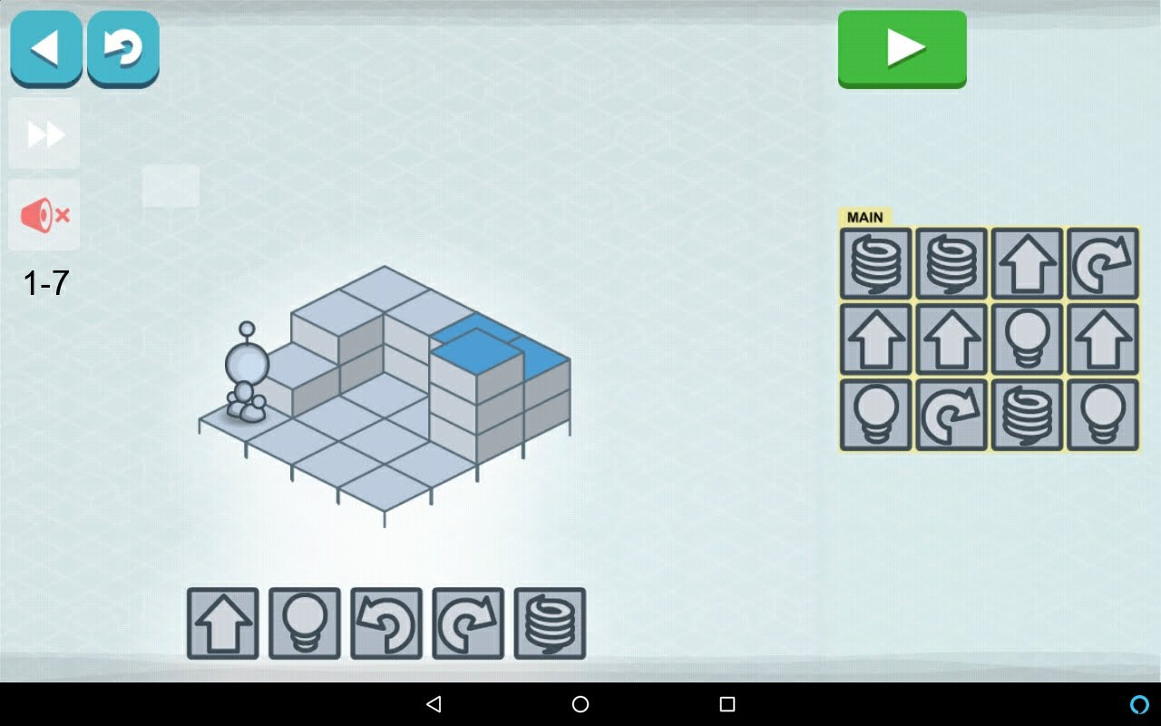
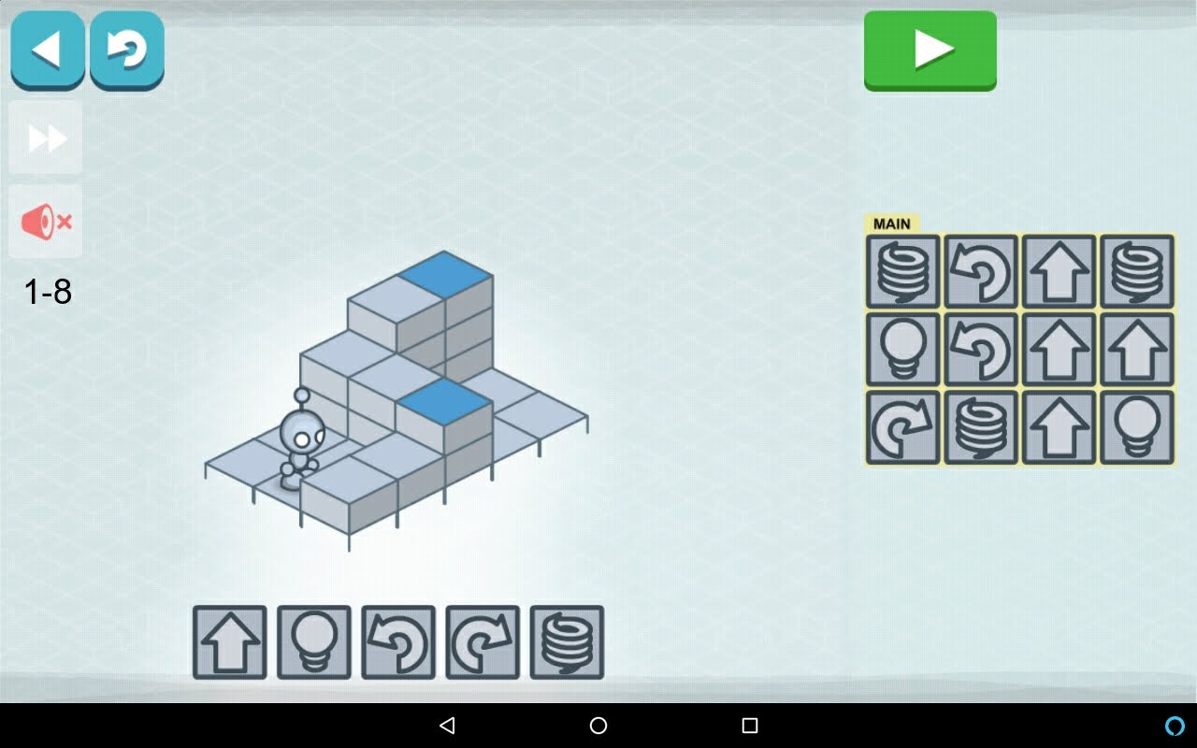
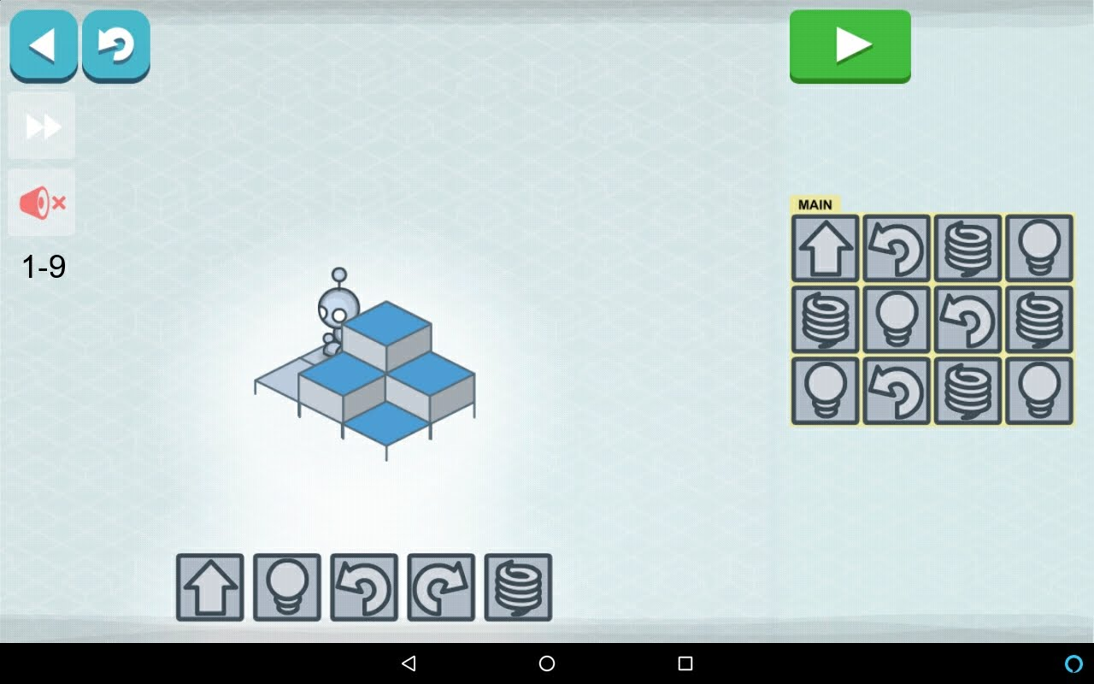

Evo Obstacle Course
- Tape two poster boards together
- Place a heavy obstacle (like a large coffee can) near the end, but leaving enough space for the robots to get around it
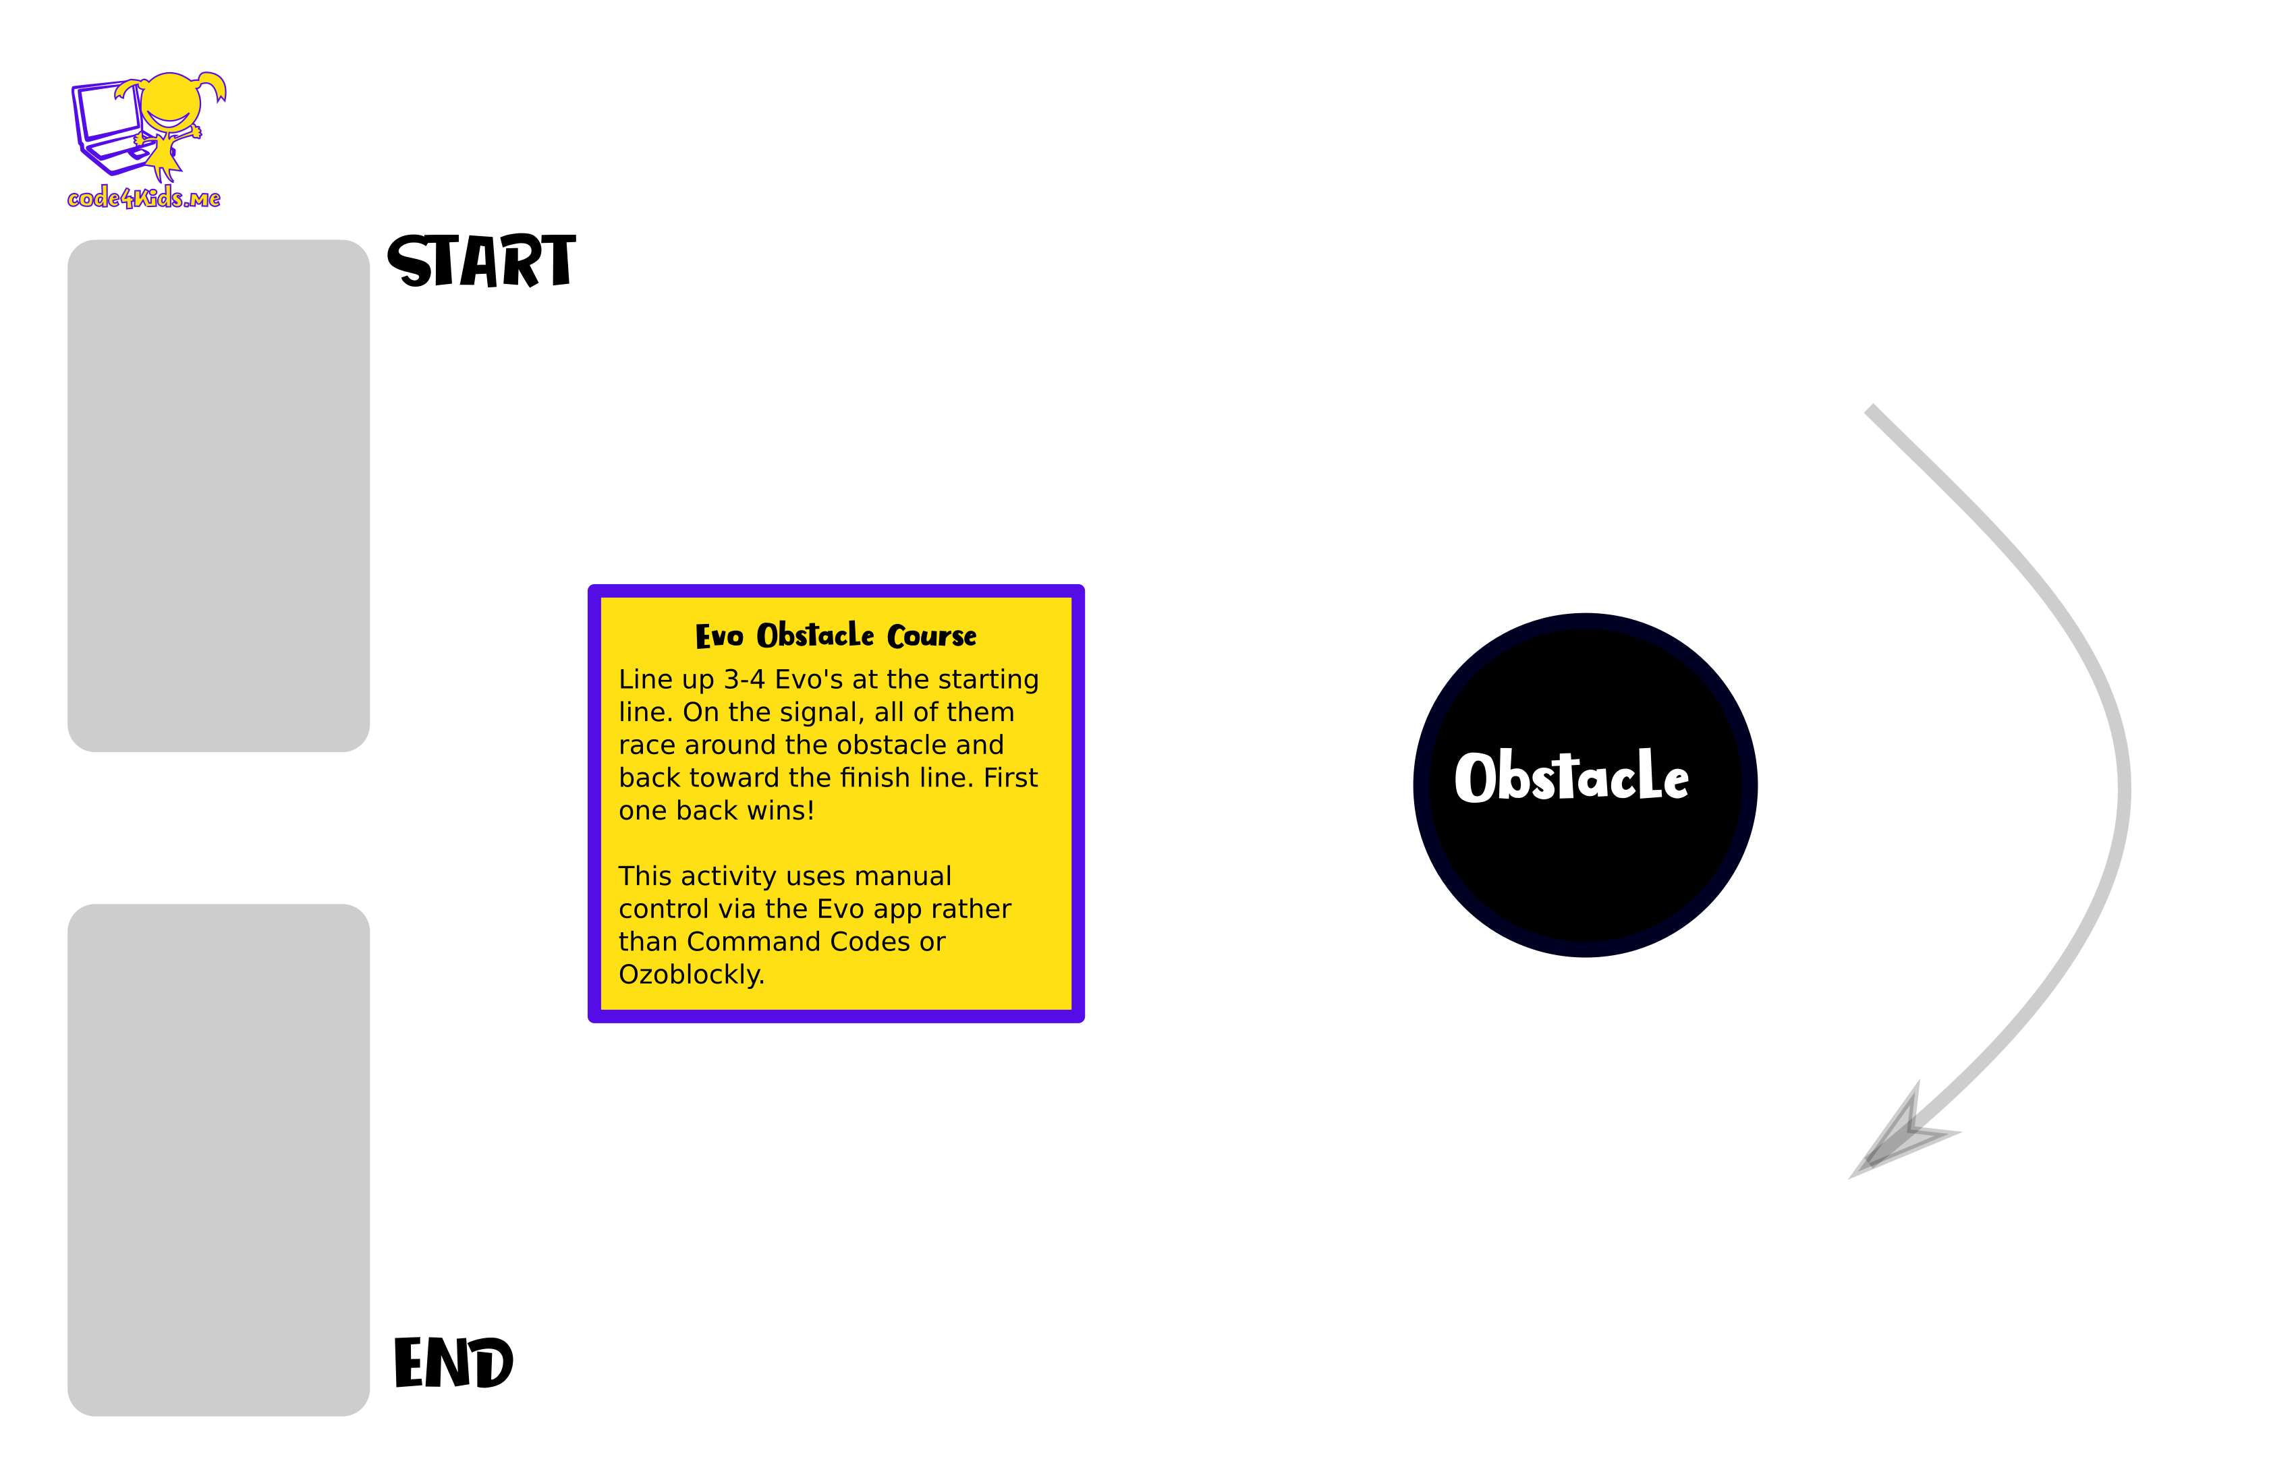

Day 2 (Tuesday)

Supplies
- Tablets and Evo’s for each kid  - Real Life Lightbot Supplies  - 10 white posterboard  - 1 blue posterboard  - 1 yellow posterboard  - 4 black posterboard  - Stacks of command cards: Forward, Right, Left, Jump, Light On, P1 | - Name tags from Day 1  - Evo Discus: Foam and poster board for each kid  - Demo Supplies:  - 3D Printer  - Laptop sending commands for “Cody”  - Color Code Markers and Stickers for each kid

Goals for Day 2 (Tuesday)
- Learn how the Evo follows lines on a page
- Learn how to control the Evo using Color Codes
- Understand how the Evo’s proximity sensors work
- Learn how to reuse code with Lightbot app

Schedule for Day 2 (Tuesday)
Start Time | Est. Time | Description
8:45 | 25 | Registration
9:10 | 5 | Review Yesterday + Questions?
9:15 | 5 | Demo: 3D printing “Cody” name tag or Code4Kids logo [inspiration, visual]  Explain that this is same as Lightbot: move around + drop filament is like “light on”
9:20 | 5 | Evo Line Following [art, visual, tactile]  Draw lines in various colors and watch Evo follow  Point out that top light changes to show color underneath  Point out that Evo randomly picks a direction at an intersection  Share that Evo can detect a sequence of colors to follow instructions (ex: “turn left”)
9:25 | 5 | Color Code Lightbot 1-1 (complete the line) [visual, tactile, code]
9:30 | 5 | Color Code Lightbot 1-2 (turning with markers) [visual, tactile, code]
9:35 | 10 | Color Code Maze 1 (fill in blanks with markers) [visual, tactile, code]
9:45 | 10 | Color Code Maze 2 (stickers with no blanks) [visual, tactile, code]  Extra Credit: student guide has more activities inside  * Color Code badge for all
9:55 | 30 | Blast Off! game [social, visual, tactile, code, competition]  Extra Credit: Draw your own shape and use Color Codes to guide Evo to trace it  * Gold, Silver, Bronze badges for first three finishers + Blast Off! Badge for all
10:25 | 30 | Snack  Make a multi-colored “maze” with your snack food [social, food, art, tactile, visual]  * Most creative snack badge  Leaders: setup Evo Discus while kids eat AND load “Rev Up” on tablets
10:55 | 15 | Evo Discus (sensors, events, motor) [social, competition, tactile, visual]  Extra Credit: Draw a circle big enough for Evo in a color – play “golf” to get Evo on that spot  * Gold, Silver, Bronze badges for top three distances  * Evo Discus badge for all
11:10 | 15 | Real Life Lightbot 2-1 (procedures/functions) [social, visual, code, audio]
11:25 | 30 | Launch Lightbot on tablet and do all of the challenges in Level 2 [screen, code]  * Lightbot 2 badge for all  Leaders: help kids when they’re stuck with a level, but try to talk them through it rather than giving them the answer
12:00 |  | GO HOME
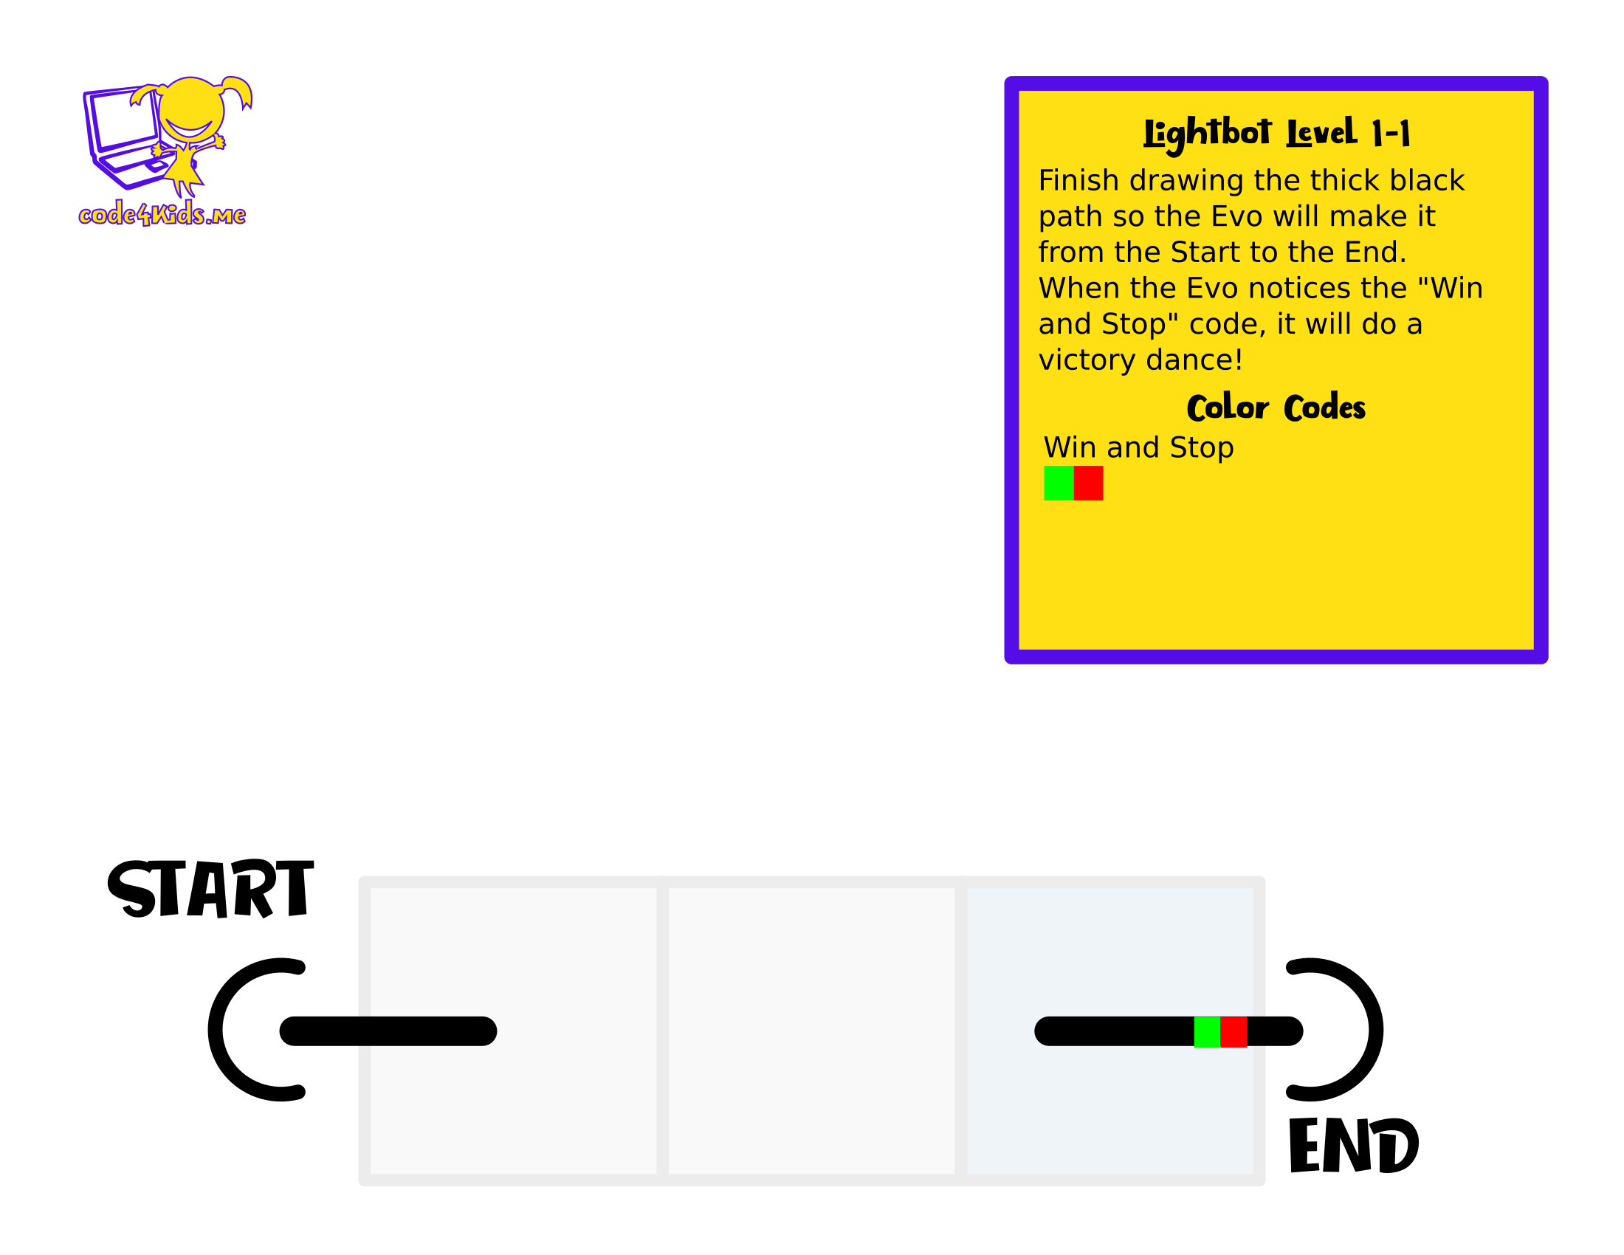
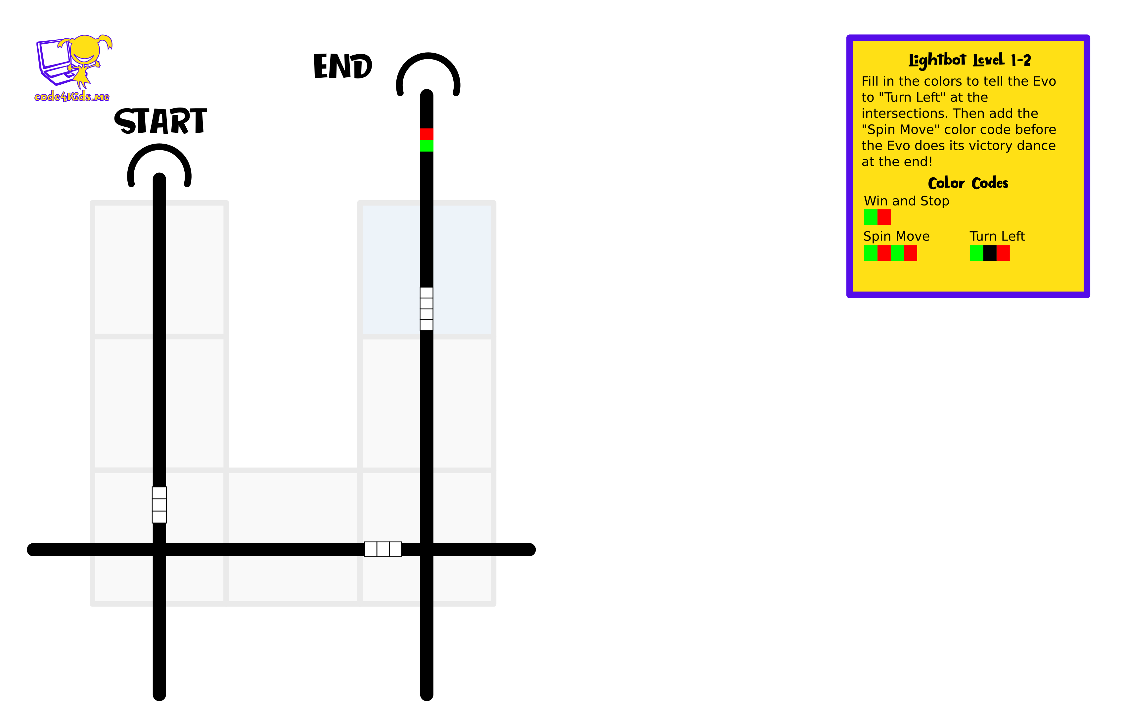
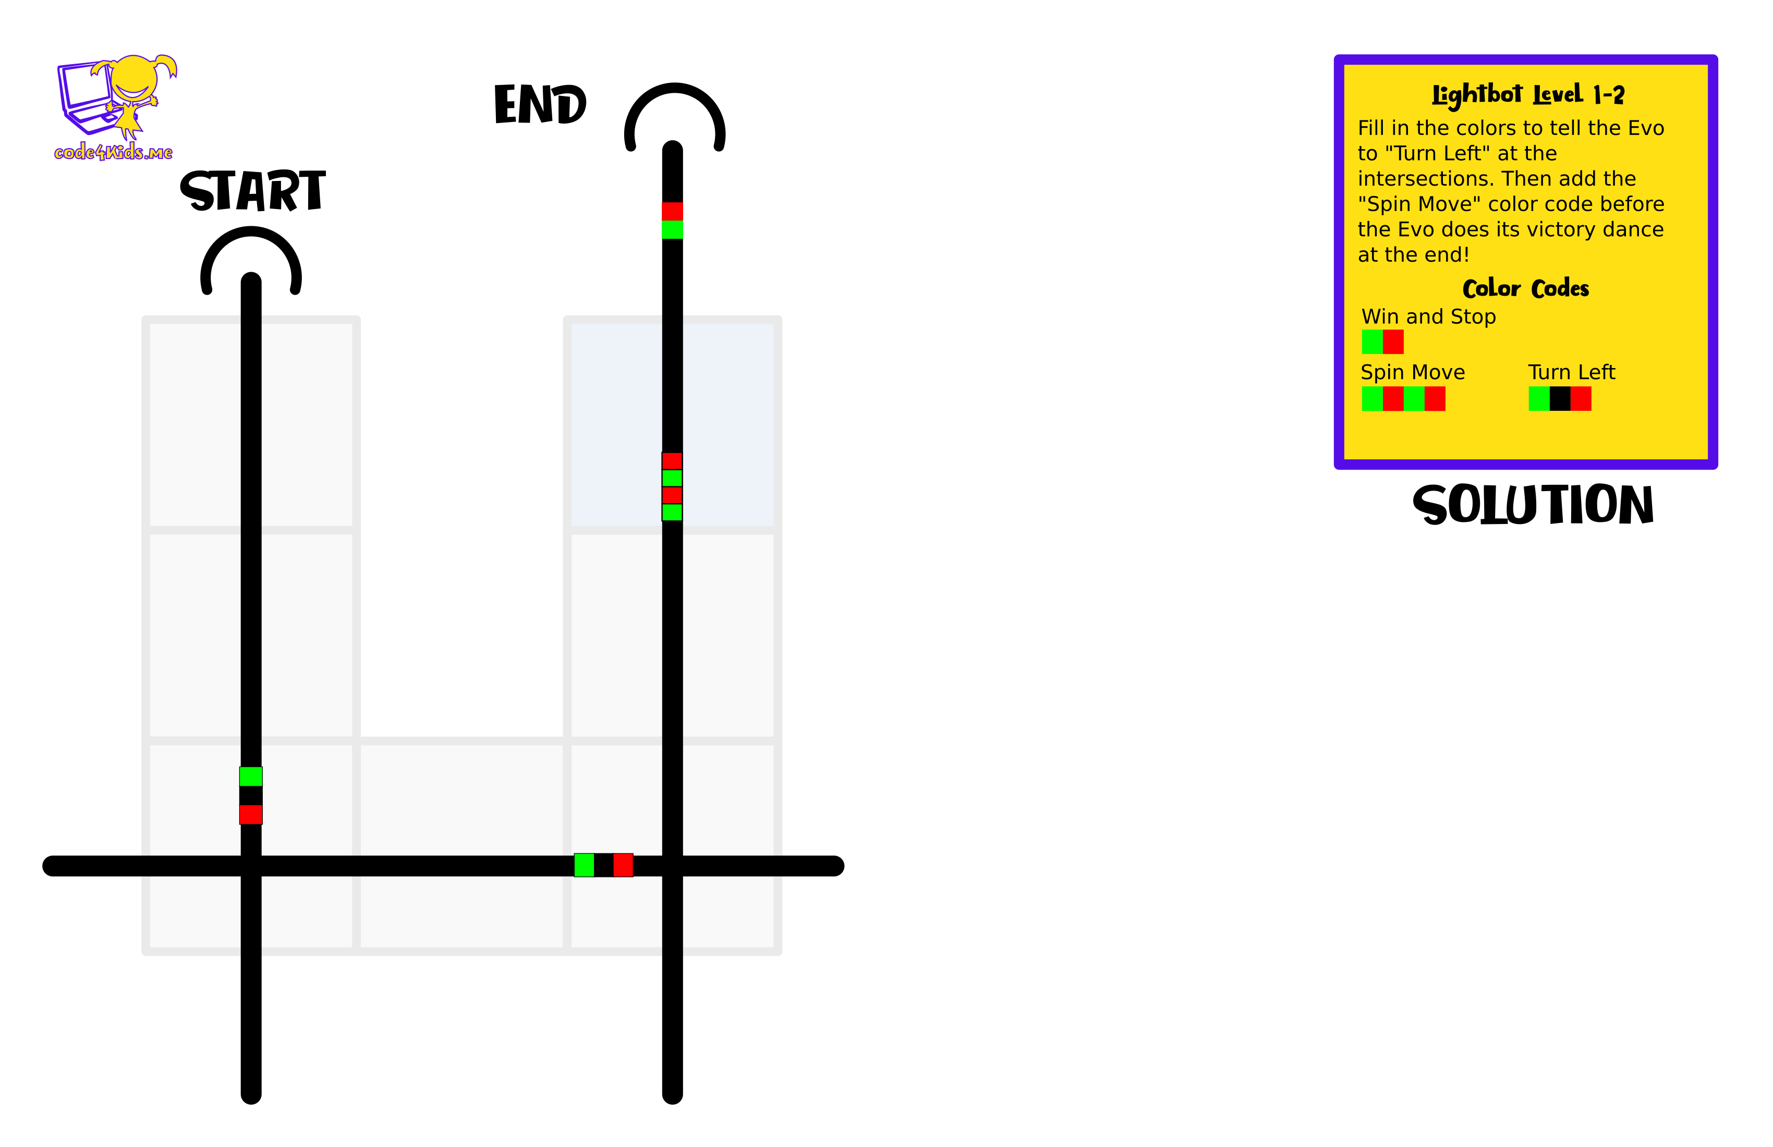

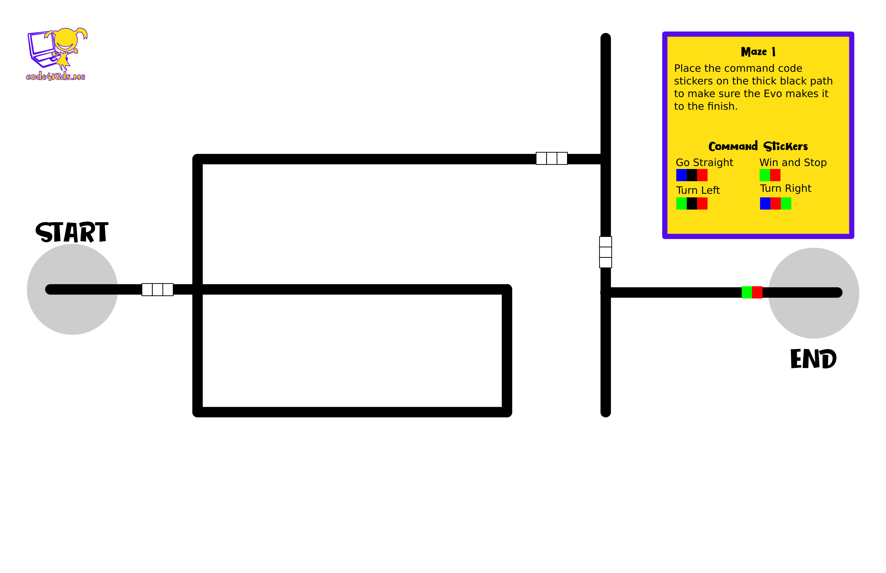
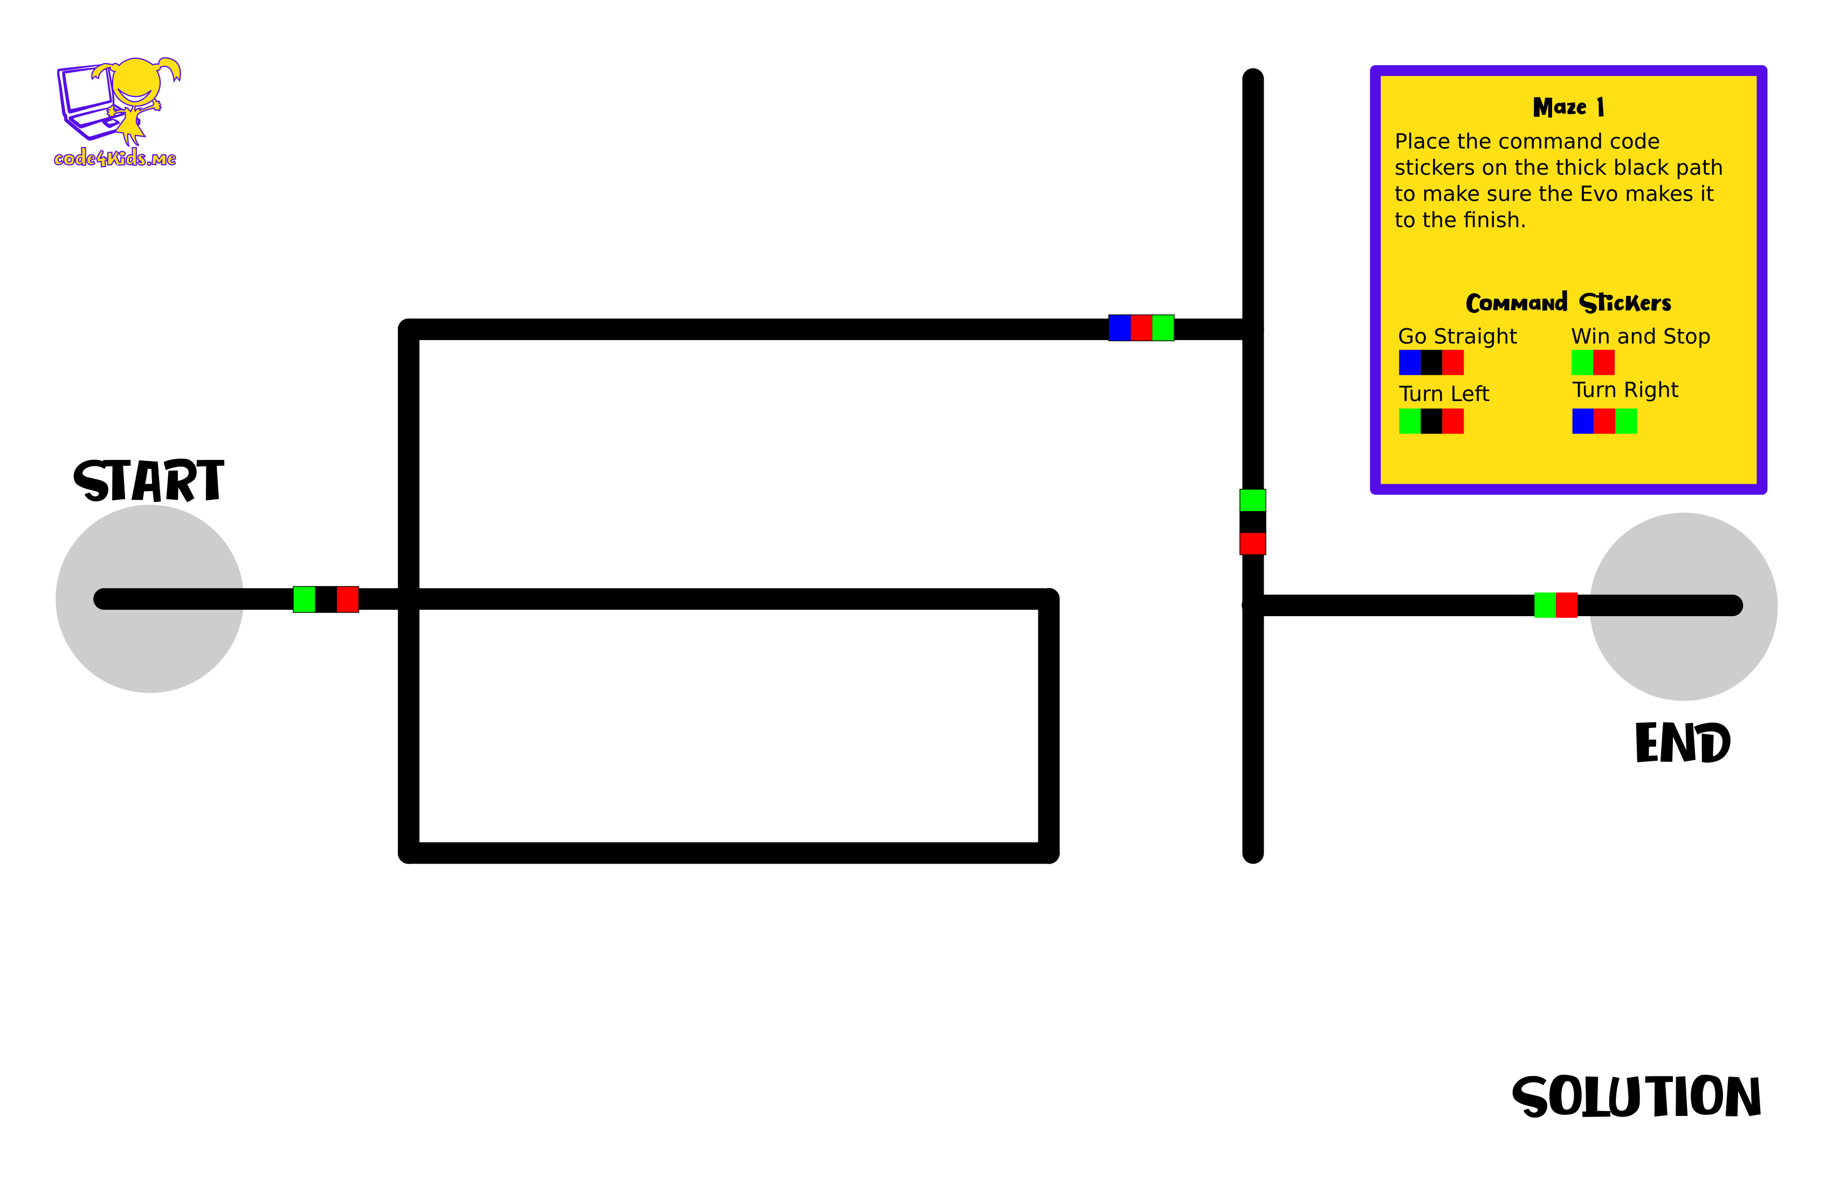
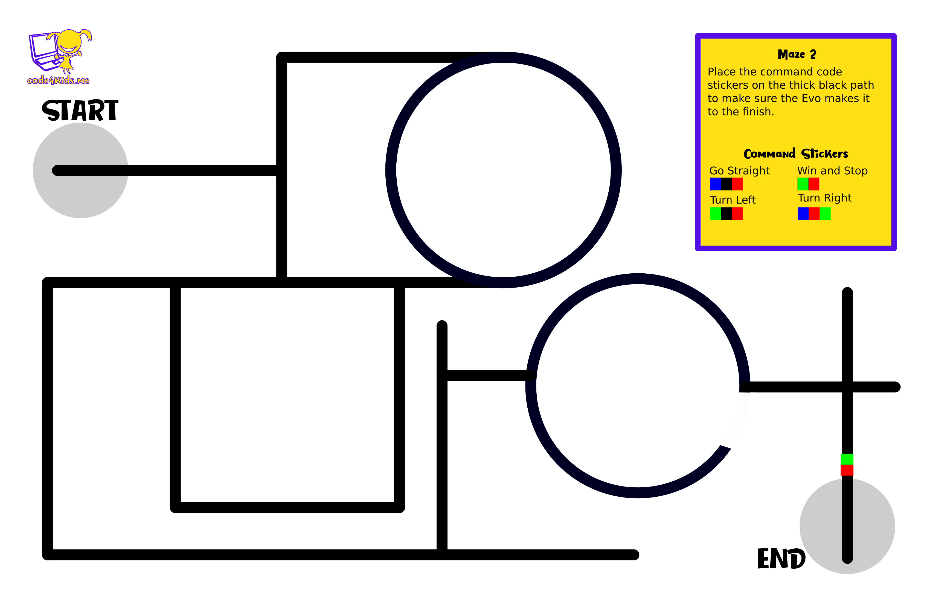
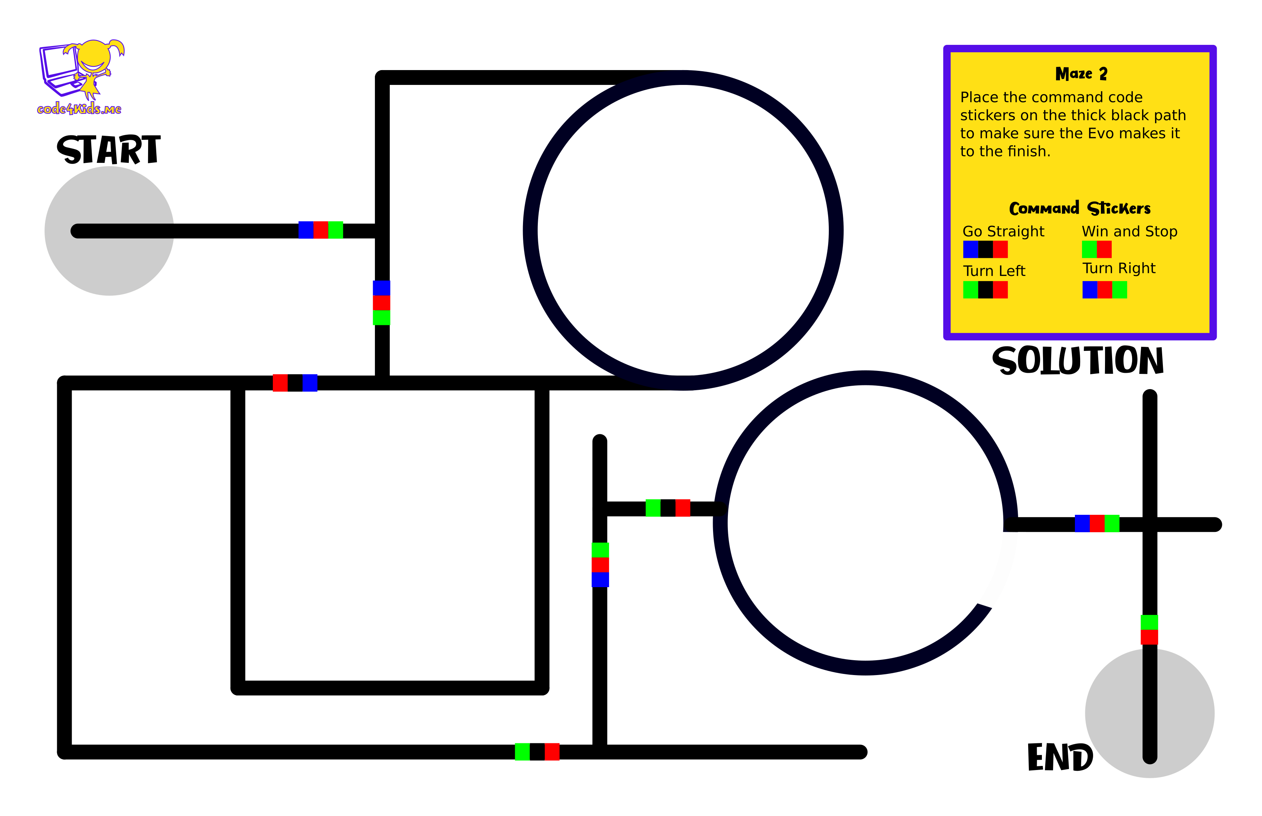

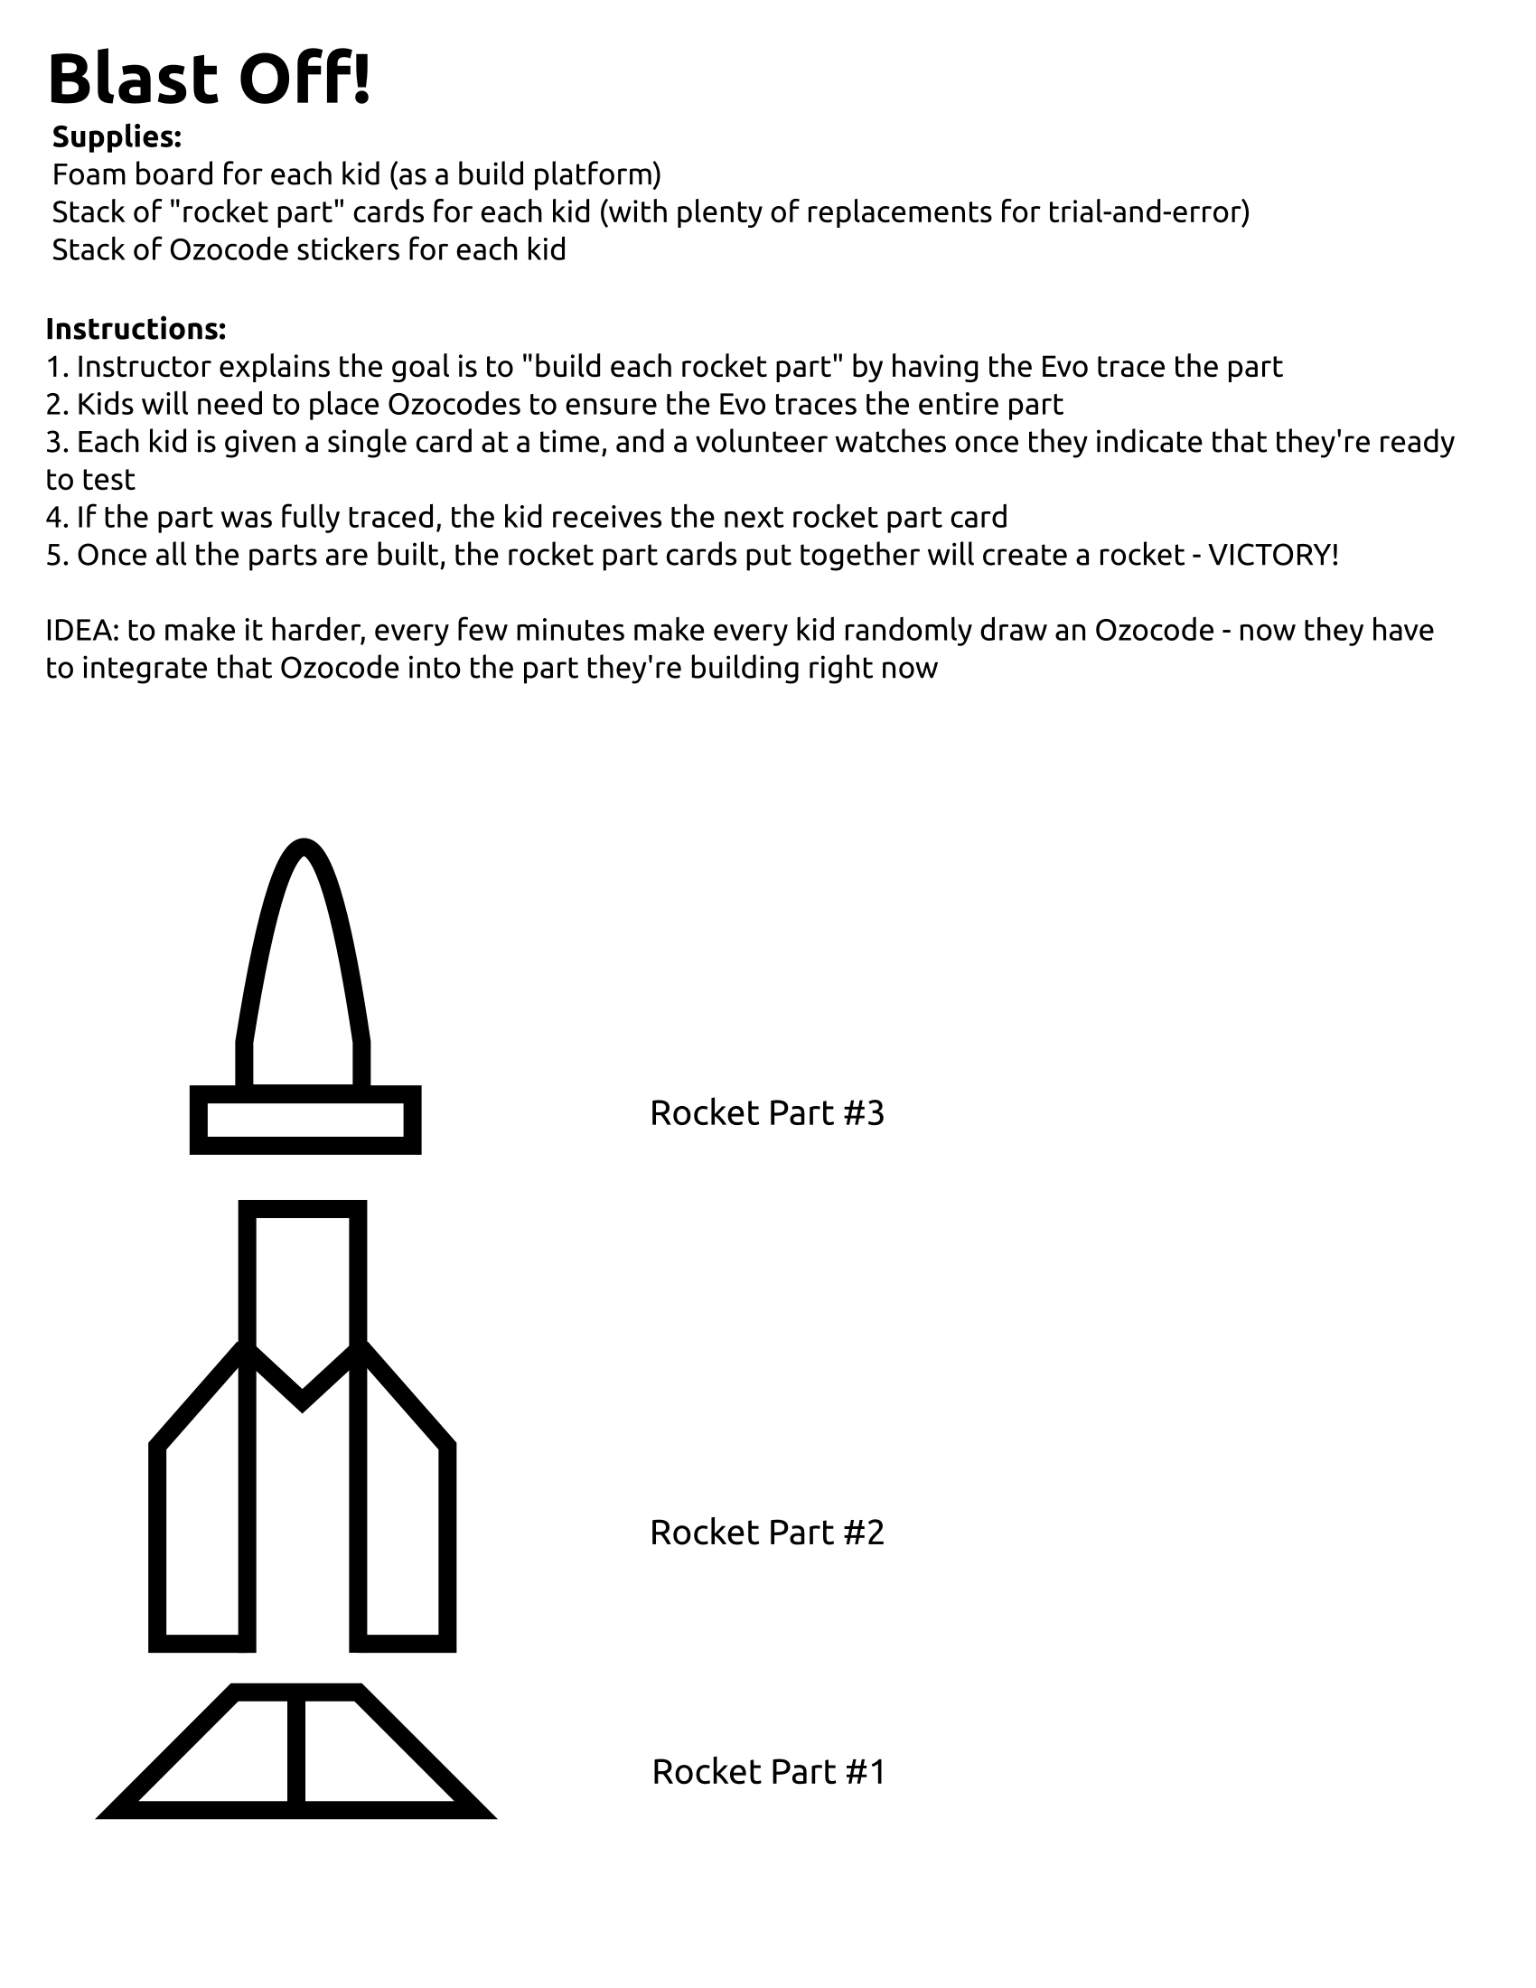
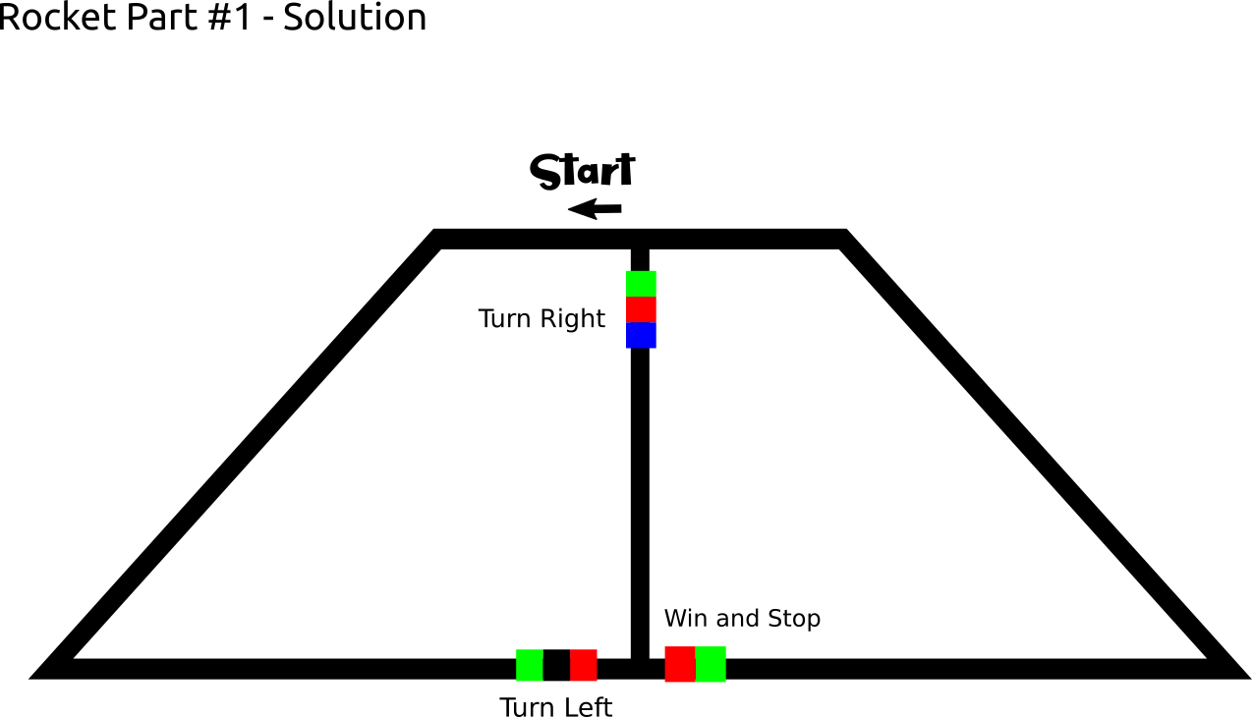

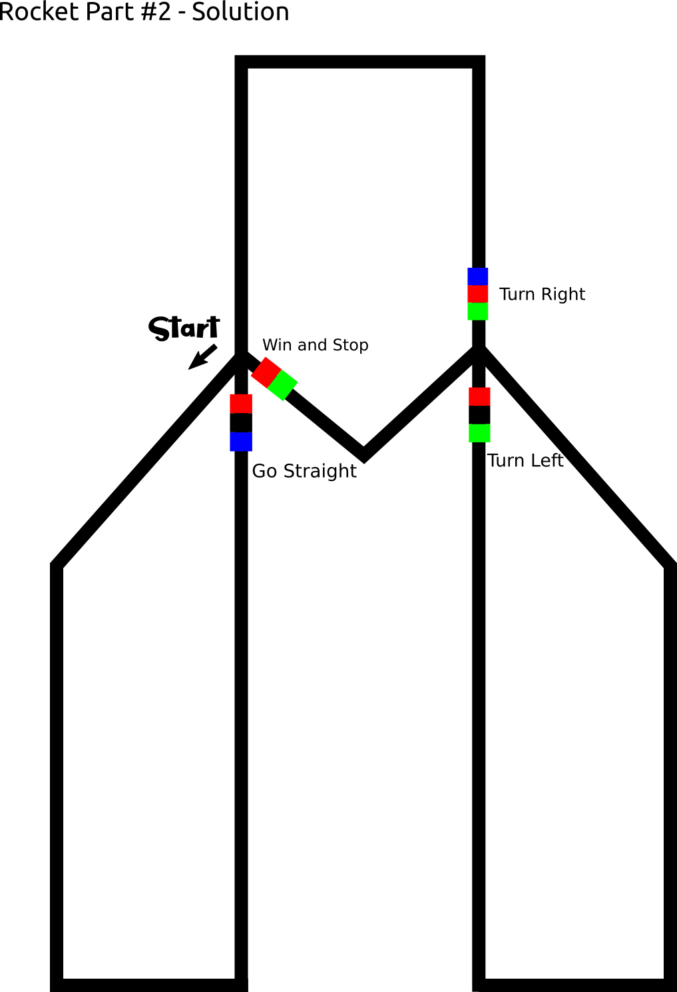
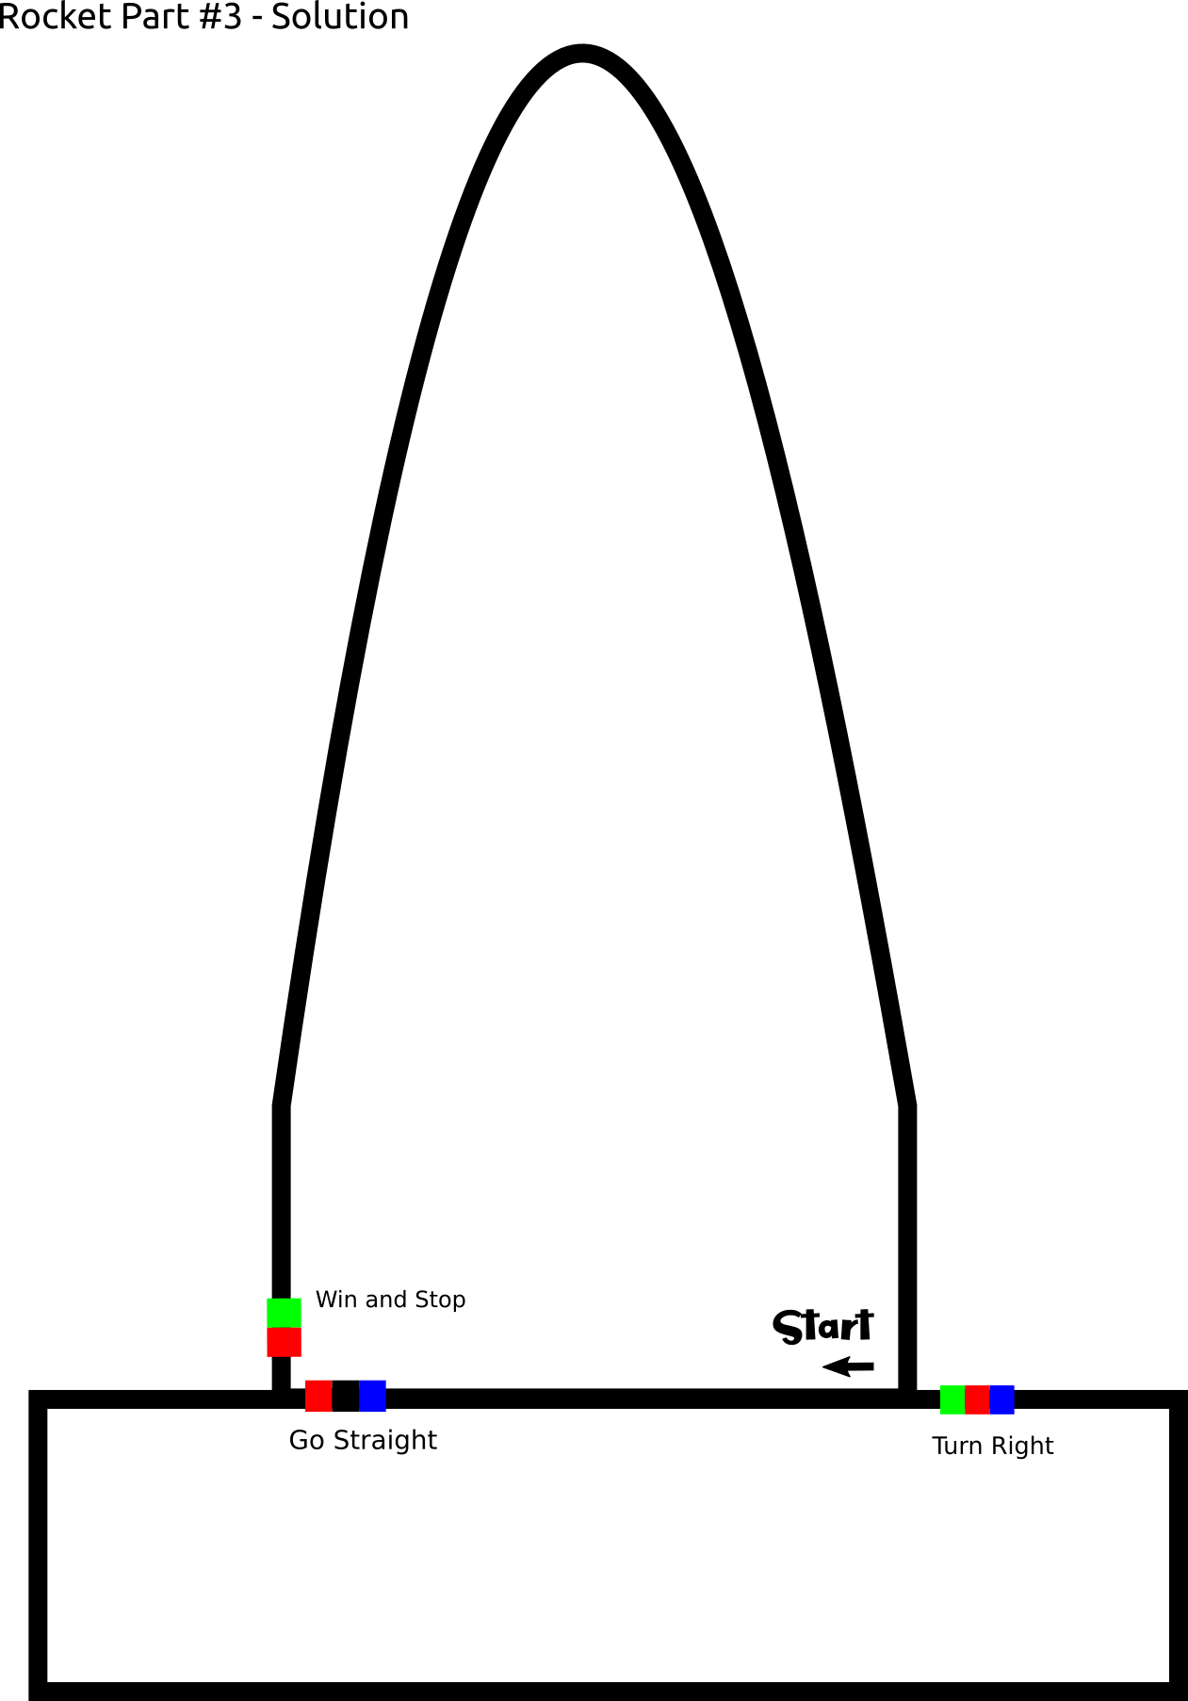

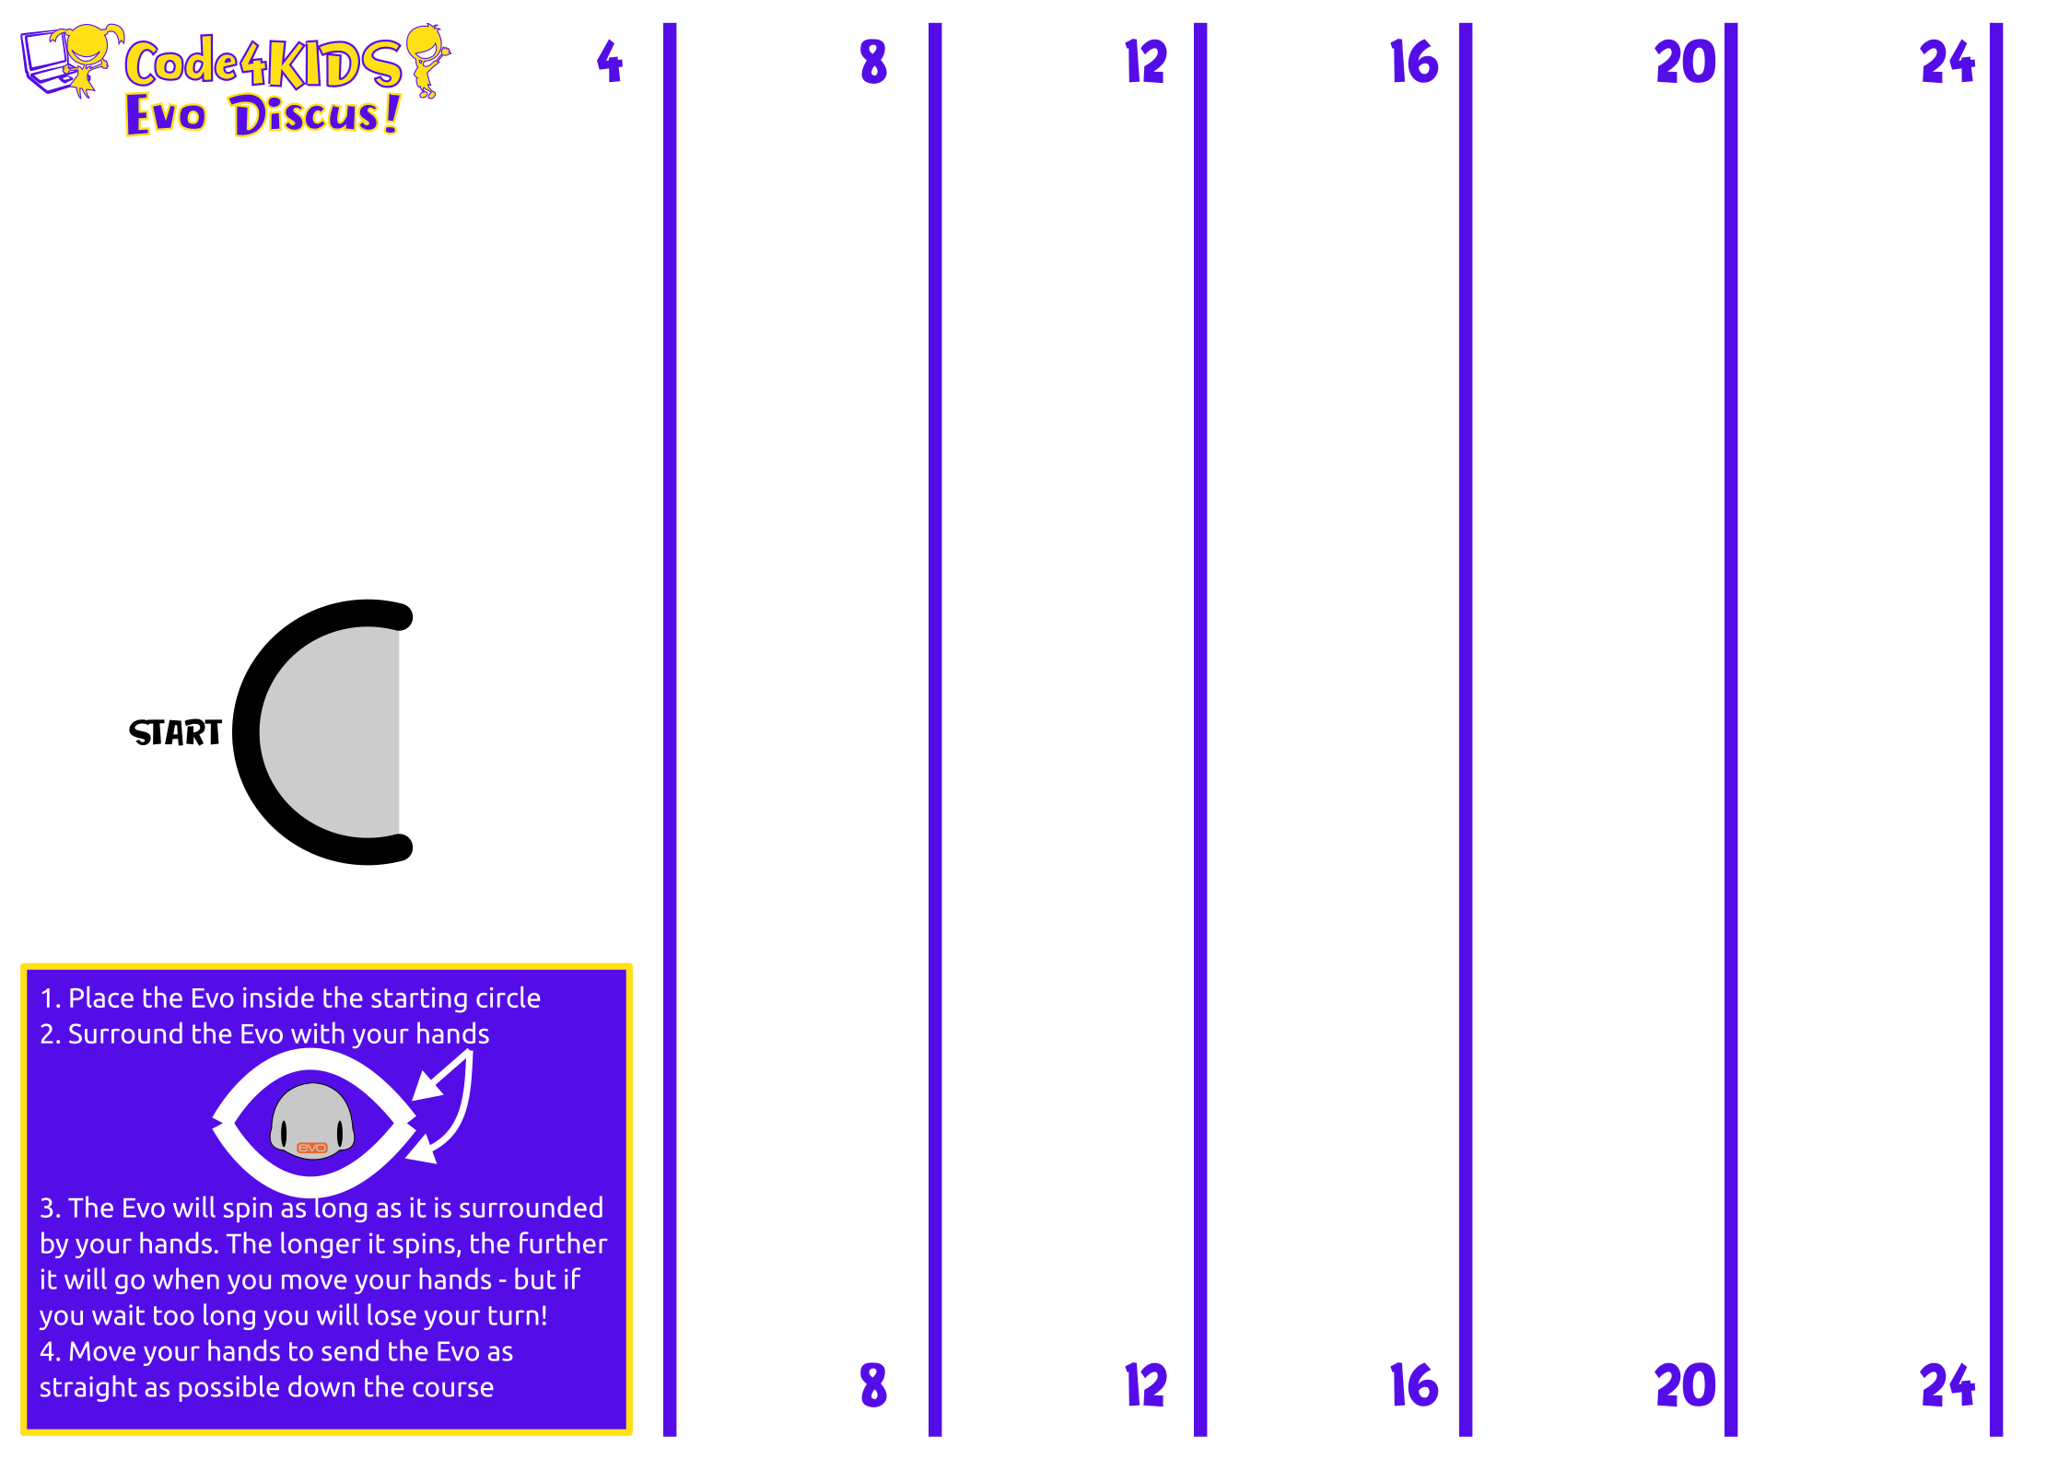

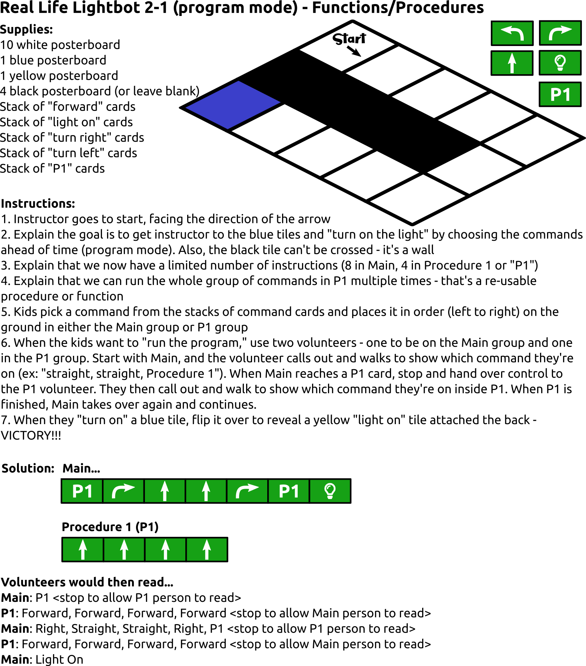

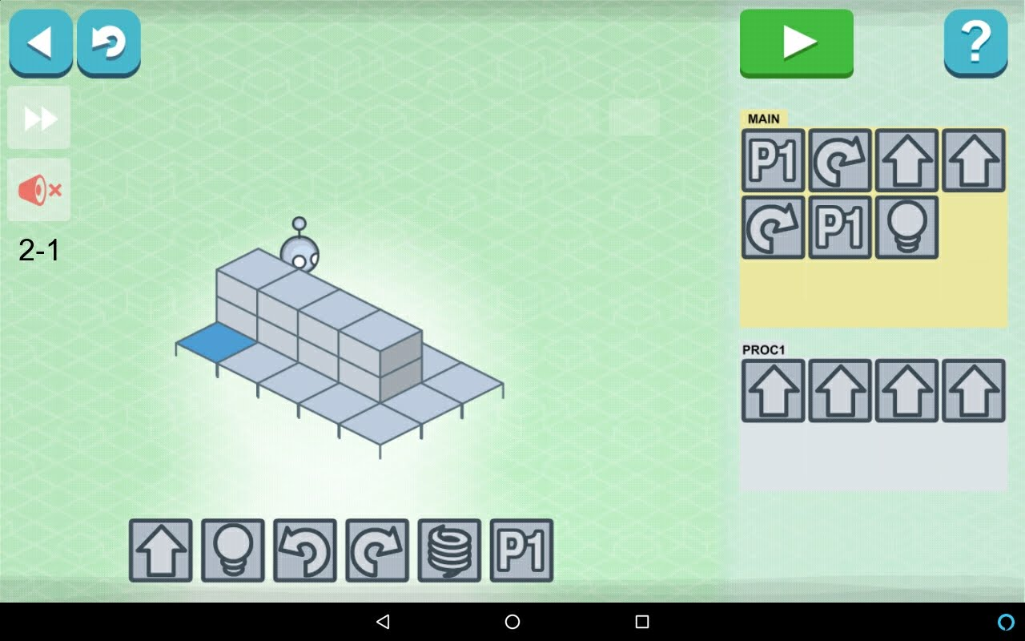
Lightbot Level 2
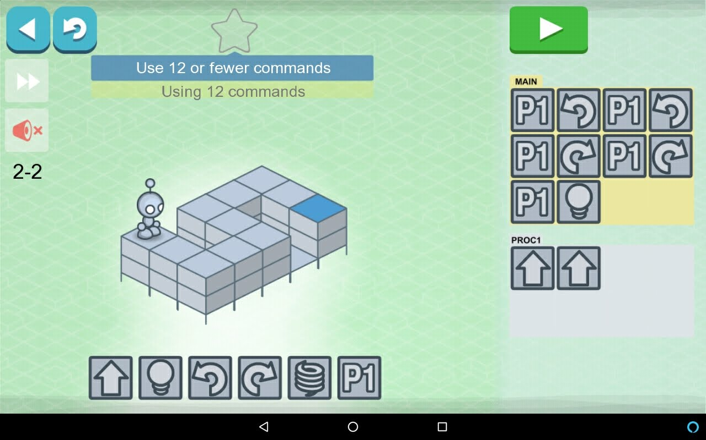
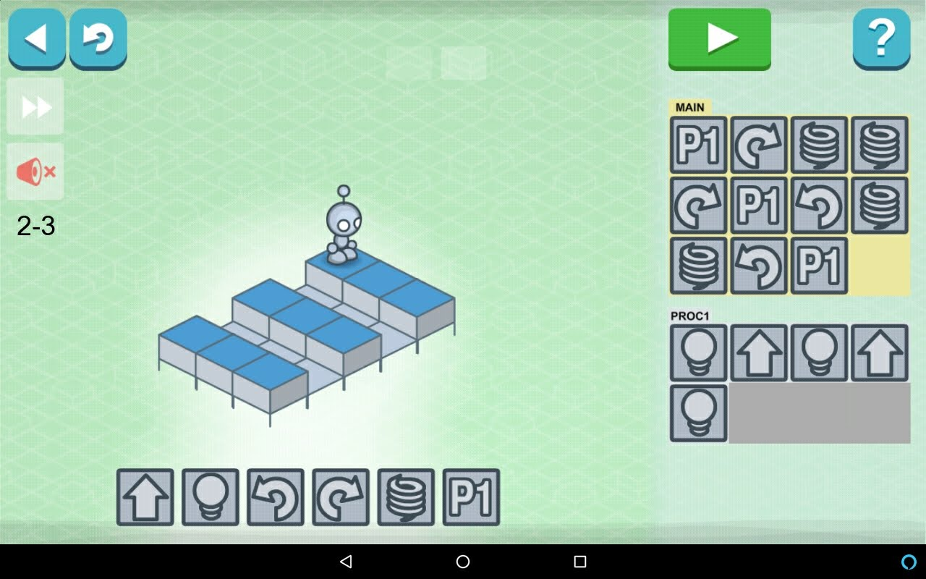
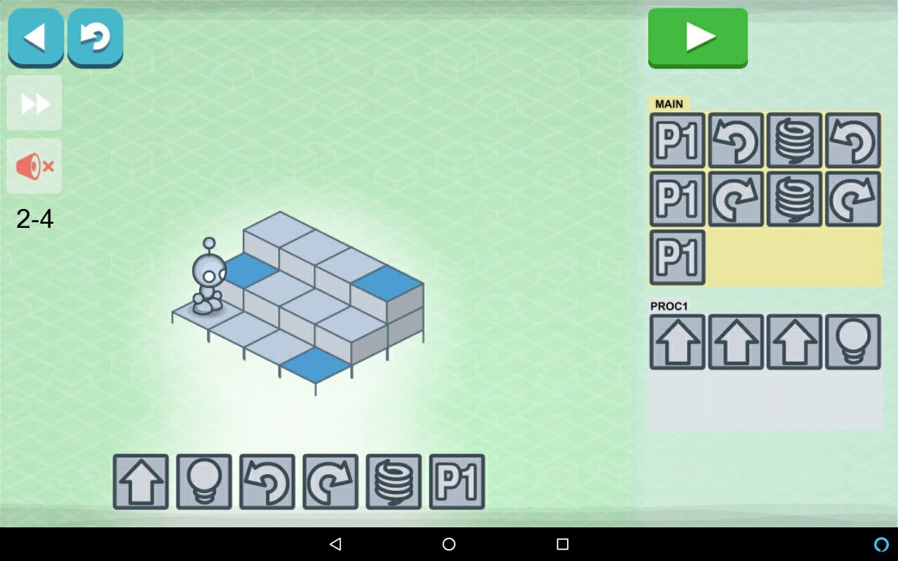

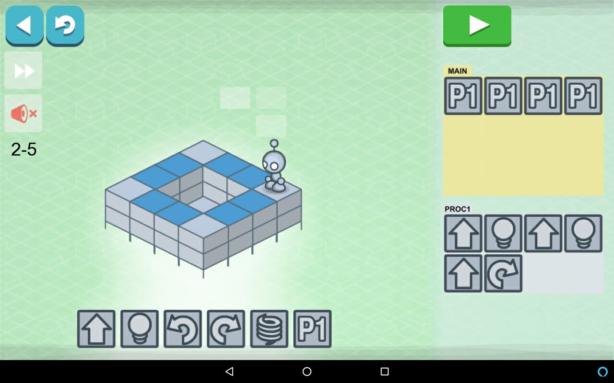
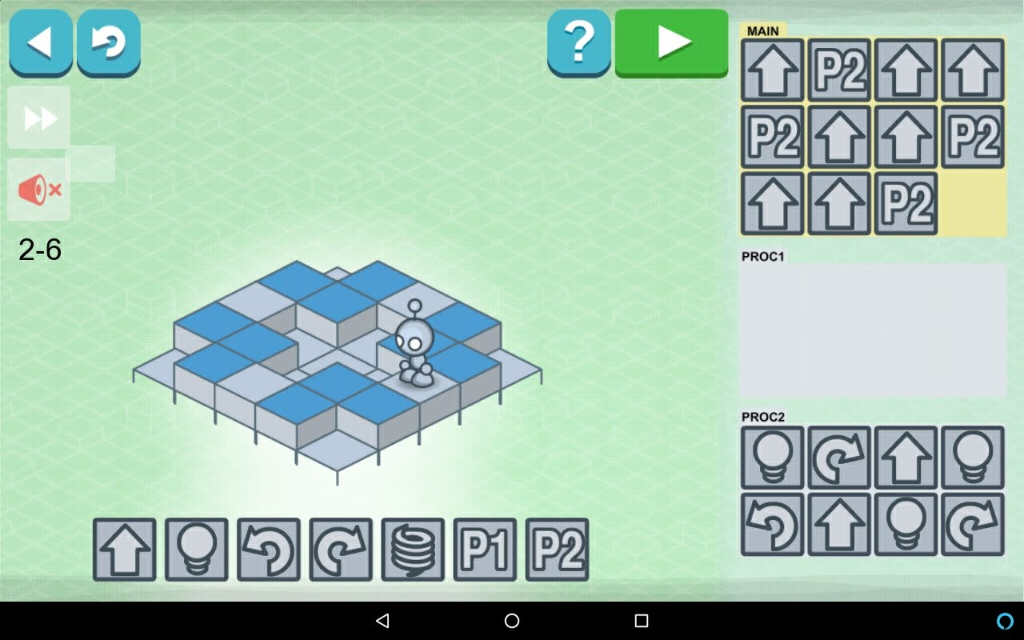
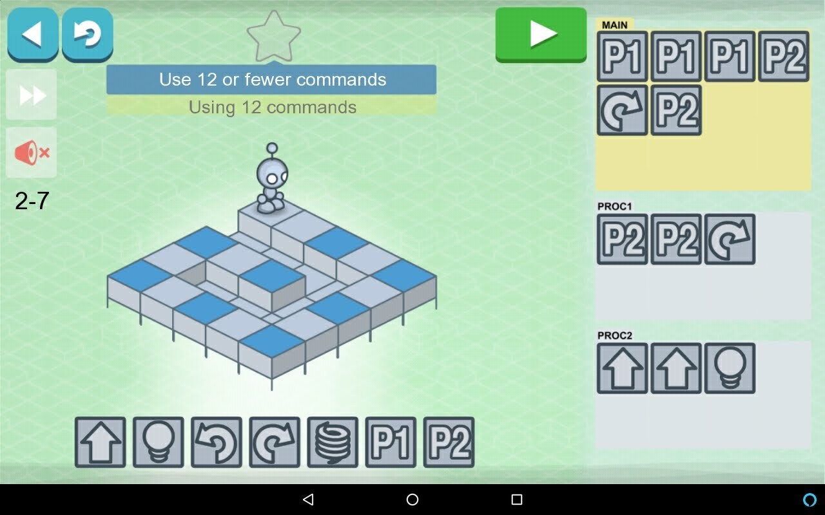
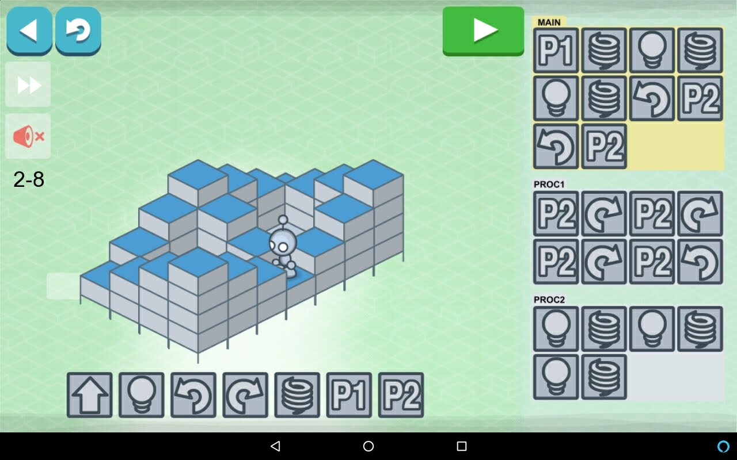
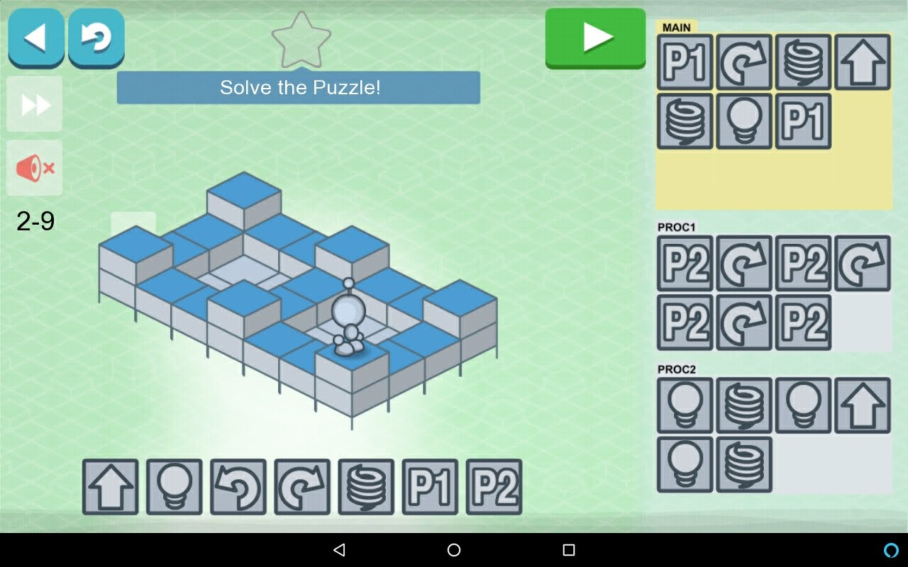

Day 3 (Wednesday)

Supplies
- Tablets and Evo’s for each kid  - Obstacles for each kid  - Laptop to show Blockly code | - Name tags from Day 1  - Demo Supplies:  - Trivia Game written and loaded on Google Assistant  - “OK Google, Talk to Code4Kids” - trivia game

Goals for Day 3 (Wednesday)
- Use OzoBlockly to program the Evo with a visual programming language
- Learn how to use loops to program repetitive behavior
- Learn how to reuse code with functions
- Learn how to store information with variables

Schedule for Day 3 (Wednesday)
Start Time | Est. Time | Description
8:45 | 25 | Registration
9:10 | 5 | Review Yesterday + Questions?
9:15 | 5 | Demo: Google Assistant Trivia Game + Show them source code [inspiration, auditory, visual]  Ex: “When you need to program something that happens a bunch of times, what should you use?” => “Function” or “Procedure” or “Loop” are all good answers
9:20 | 10 | OzoBlockly Demo [visual, code]  Show them how to load up the editor, make the Evo go in a square, launch the program  Launch with Bluetooth + Calibrate and Flash (which we’ll be using in camp)
9:30 | 30 | Evo Obstacle Course with OzoBlockly [tactile, visual, code]  Program your own Evo to do the obstacle course with code, not manual control  Extra credit: add another obstacle or two and dodge those as well, make Evo go in reverse  * OzoBlockly badge for all
10:00 | 30 | Evo Dance Party [creative, visual, code, auditory, social]  Deconstruct the Evo “Fashion Runway” app that’s pre-loaded – see lights, sounds, turns  Make your own Evo dance and show the group  Extra Credit: Load “Dance Lesson” app and customize it for your own dance  * Dance badge for all  * Artistic badge
10:30 | 30 | Snack  Make an obstacle course with your food OR Show a robot dancing  * Most Creative Snack badge
11:00 | 30 | Loop Activities – repetitive behavior [visual, tactile, code]  - Go in a square pattern forever (Extra Credit: do it with only 4 blocks)  - Go in a square pattern twice, saying the direction you’re about to go/rotate AND add a spin at each corner of the square (Extra Credit: do it with only 7 blocks)  - Same as above, but add a celebration with movement, sound, and lights at end  * Loops Badge for all  * Efficient Badge for any who get the extra credit
11:30 | 30 | Function and Variable Activities – complex behavior and reusable code [visual, tactile, code]  - Slot Car Racing + function to celebrate at end of race  - Slot Car Racing + use variable and function to set different light color each lap  * Functions Badge for all  * Variables Badge for completing the second Slot Car challenge
12:00 |  | GO HOME

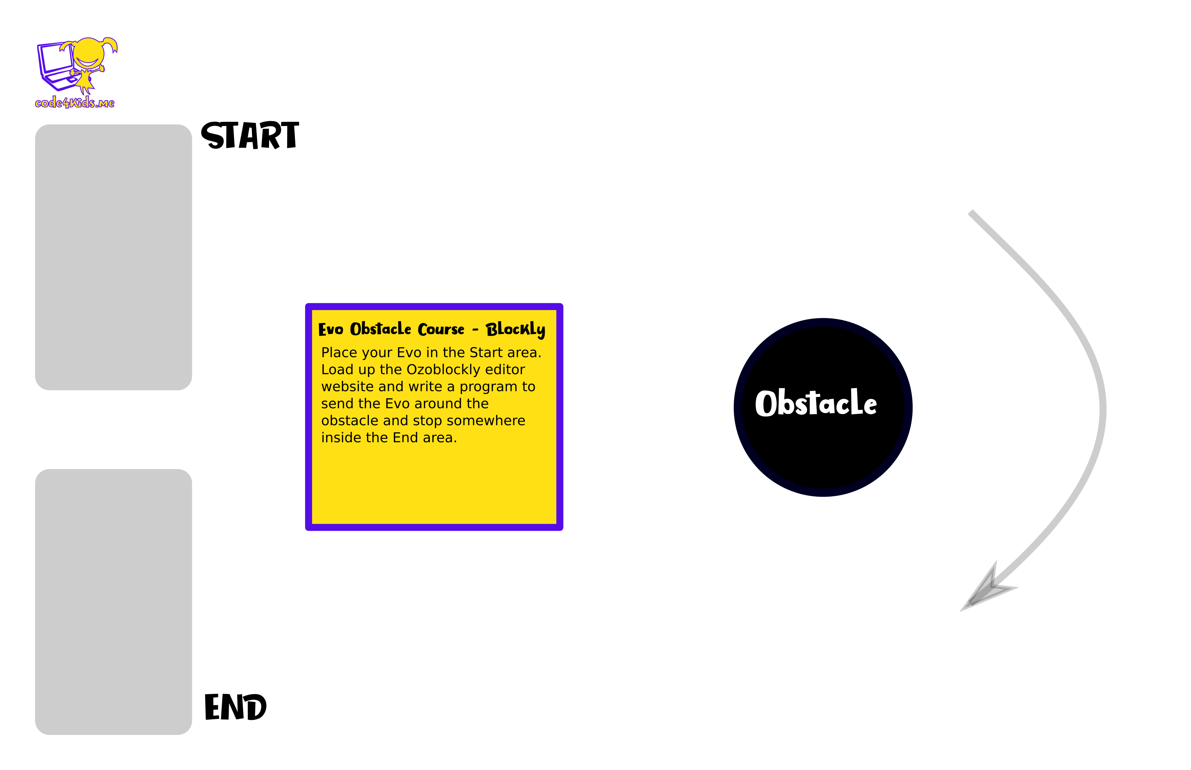
Evo Obstacle Course with Blockly

Sample Solution (Mode 2)
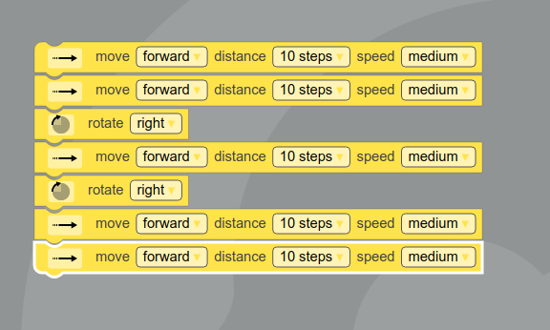

Fashion Runway
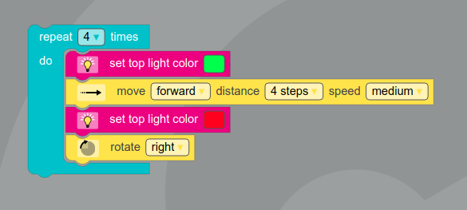

Dance Lesson
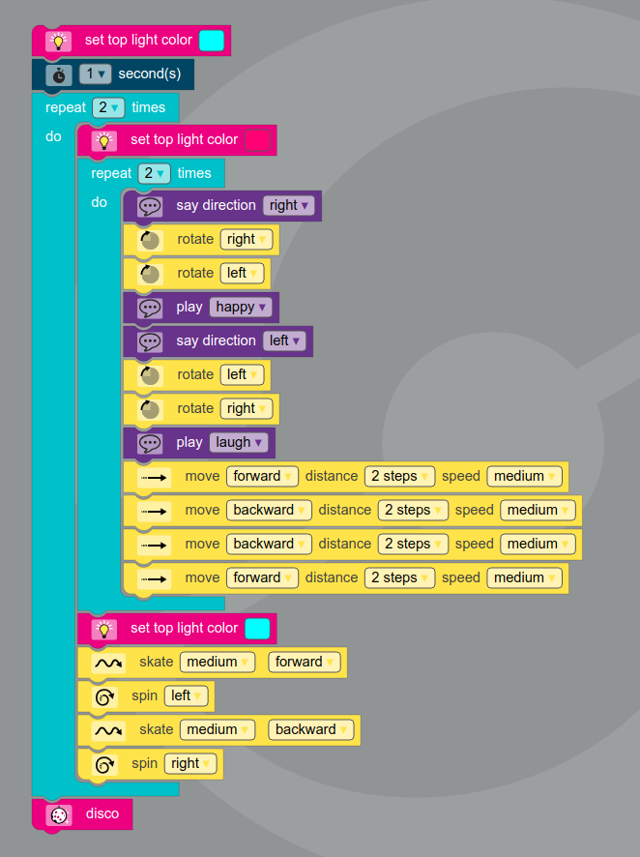

Loop #1: Square Forever (Mode 2)
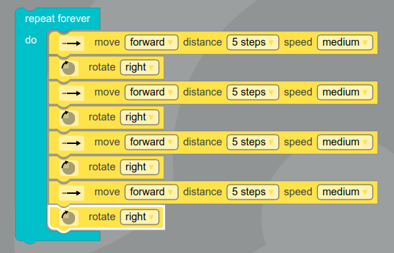

Extra Credit: 4 Blocks (Mode 2)
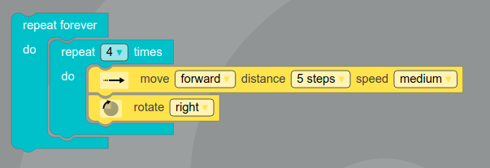

Loop #2: Square With Spin (Mode 2)

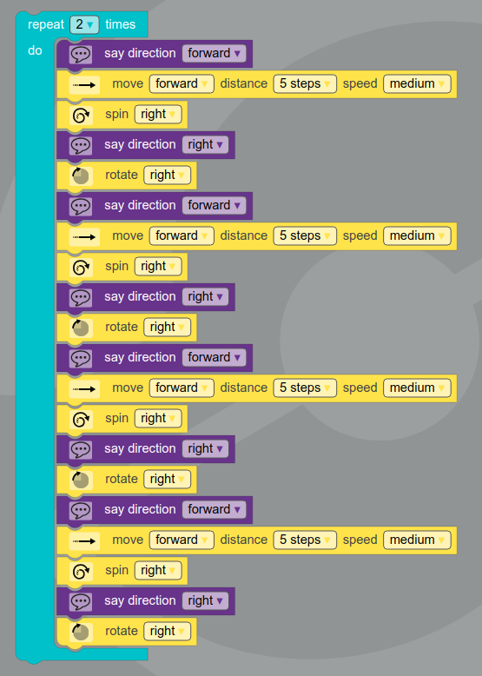
Extra Credit: 7 blocks (Mode 2)
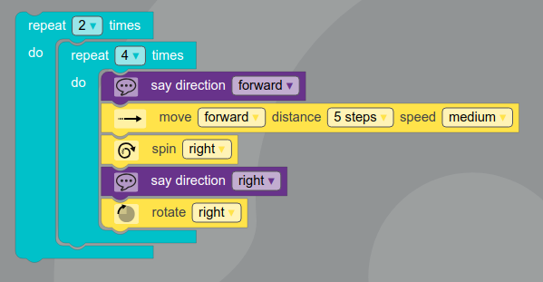

Slot Car Racing Course

Instructions (Level 1)
- Use Mode 3 (Intermediate)
- Set Evo to “very fast” speed
- Place Evo at “Start” heading in the direction shown by the arrow
- Anytime Evo encounters an intersection, go straight (just like a slot car)
- After 5 laps, celebrate with a 360 spin to the right and blinking the front LEDs green five times

Instructions (Level 2)
- Use Mode 3 (Intermediate) for movement and Mode 4 (Advanced) for variables and functions
- Set Evo to “very fast” speed
- Place Evo at “Start” heading in the direction shown by the arrow
- Anytime Evo encounters an intersection, go straight (just like a slot car)
- Use a variable to track the current lap number, and say the current lap number aloud at the start of each lap
- Use a function to set the top LED color based on the current lap number variable
#1 Red, #2 Orange, #3 Yellow, #4 Green, #5 Blue
- After 5 laps, create a function to do a celebration of your own design
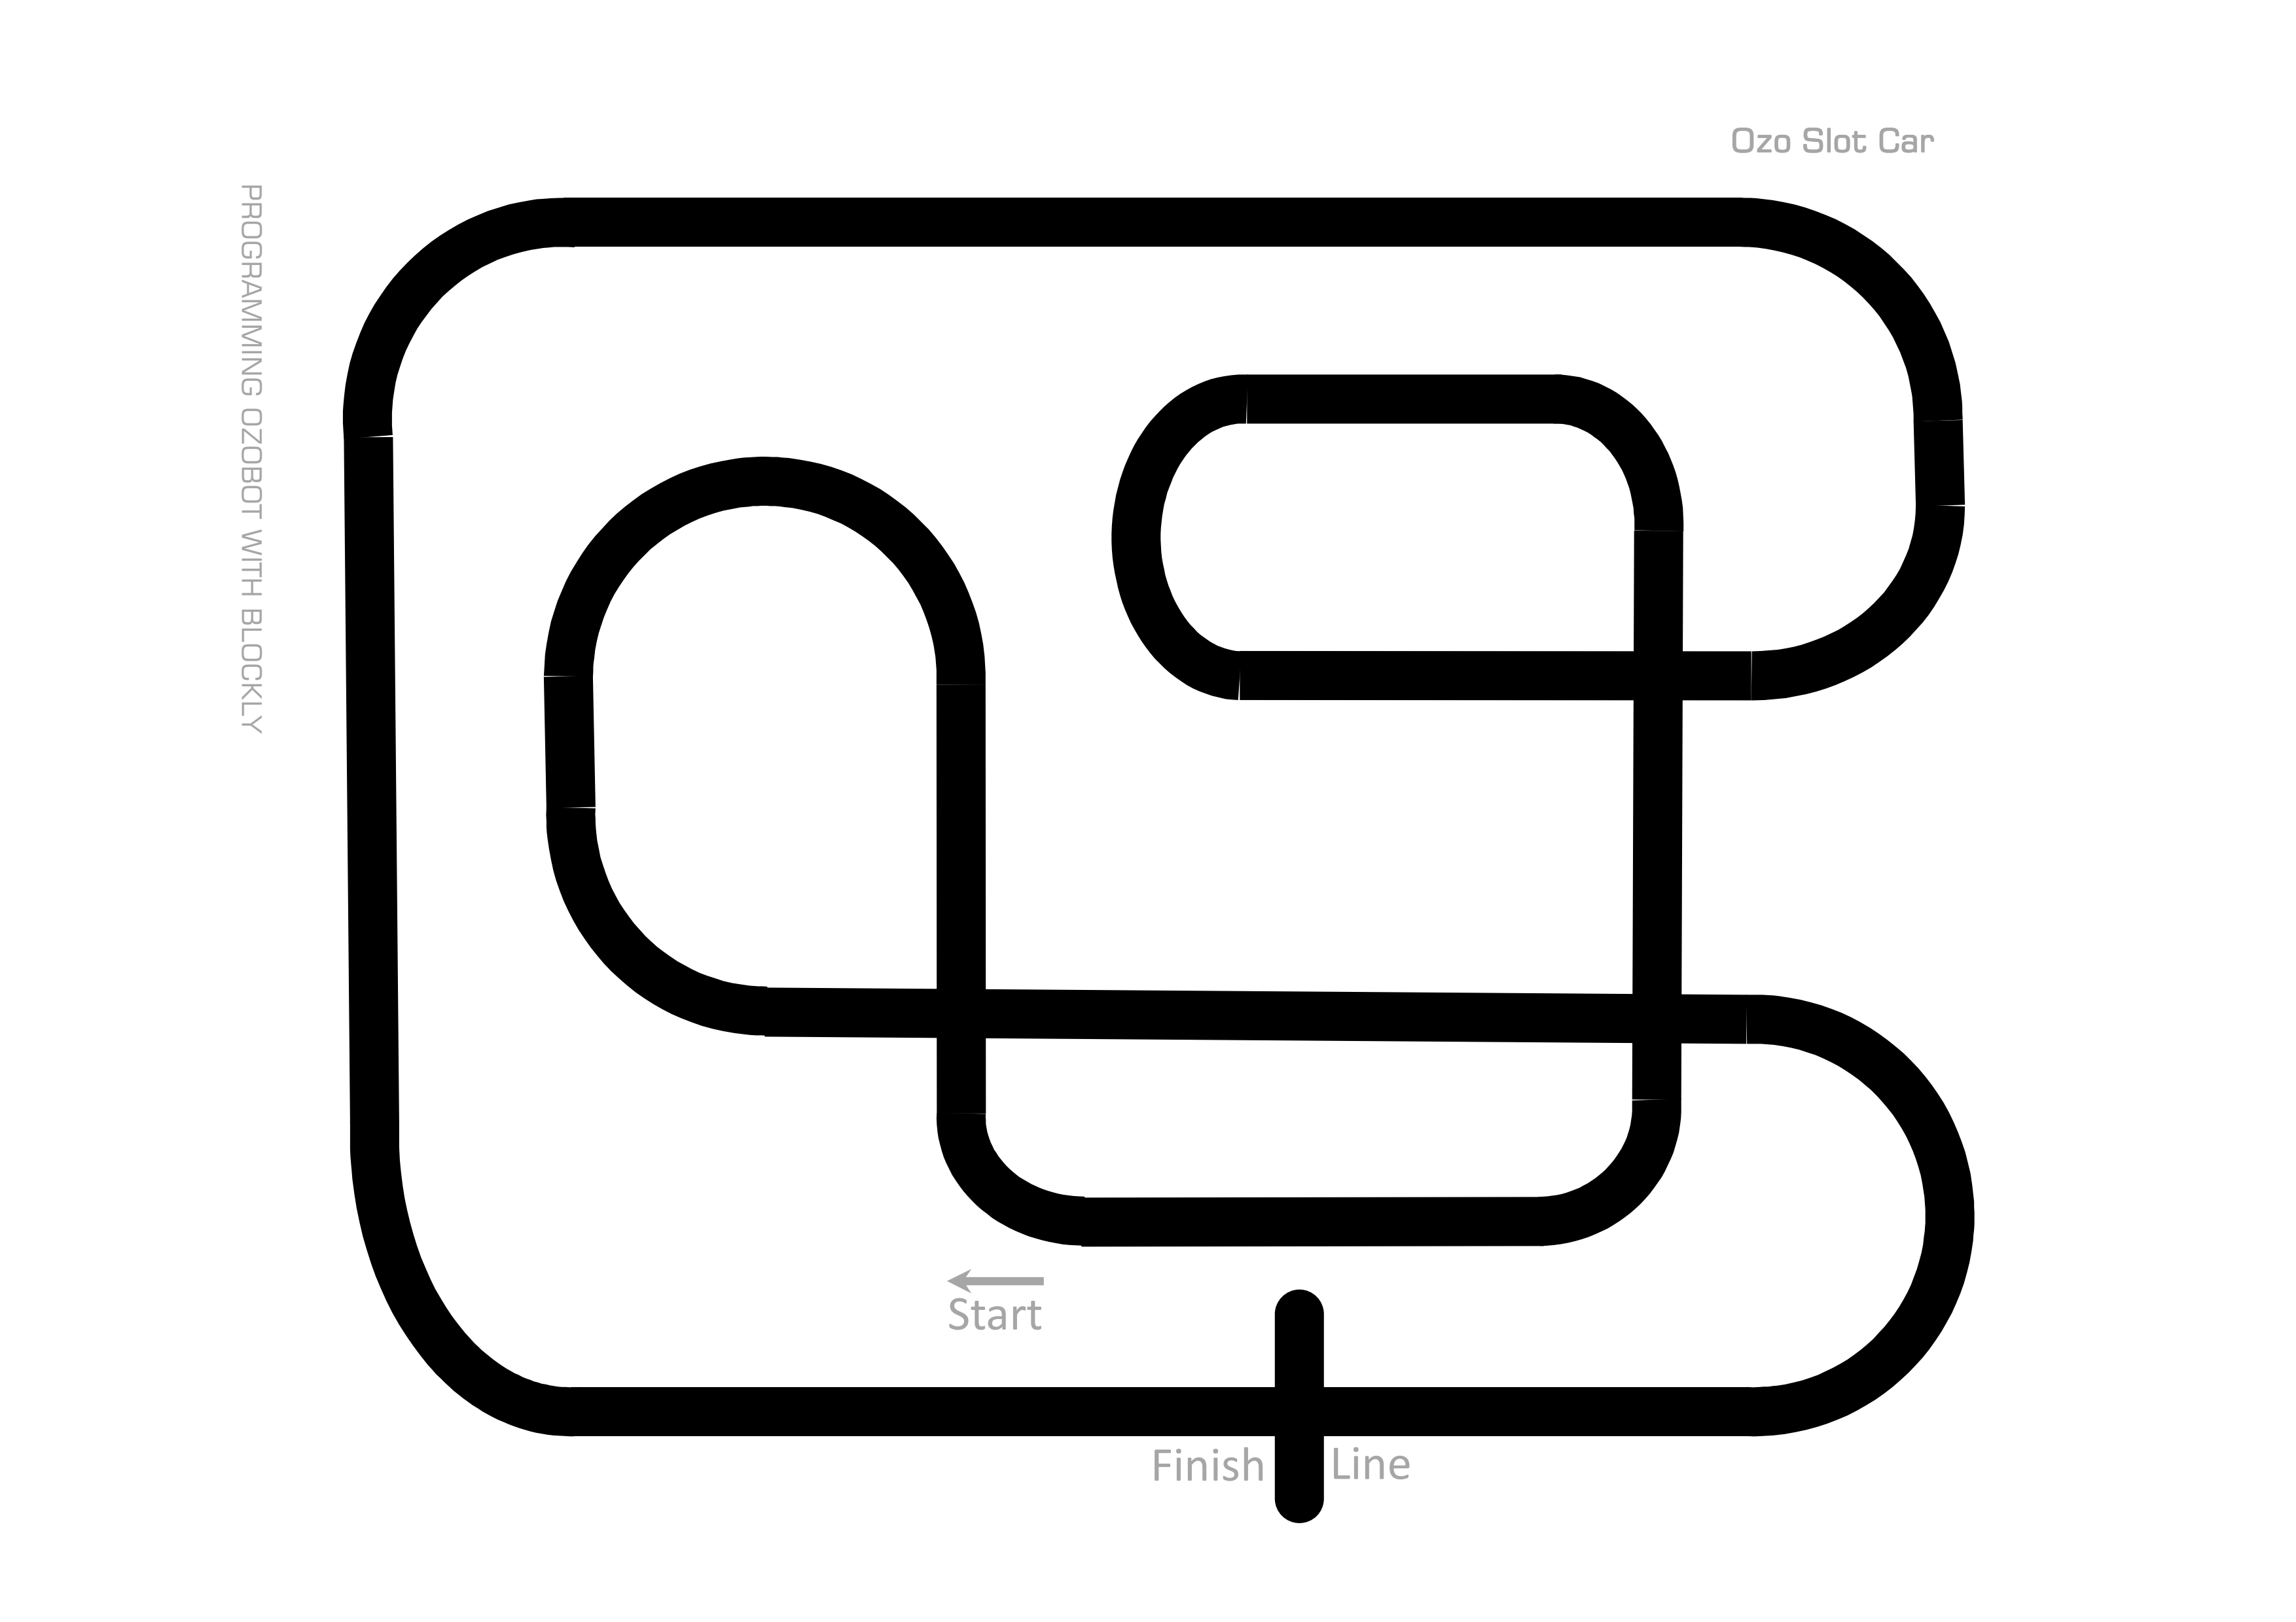

Slot Car Level 2 Solution
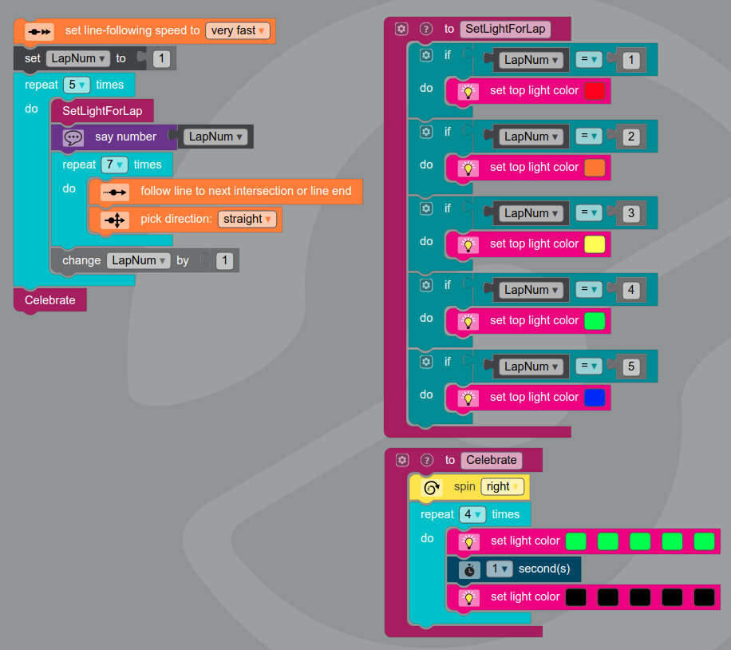

Ozoblockly Editor
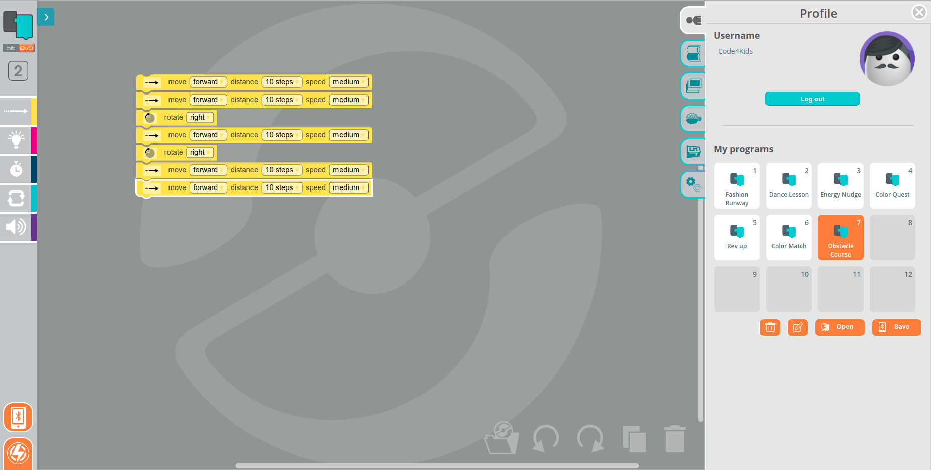
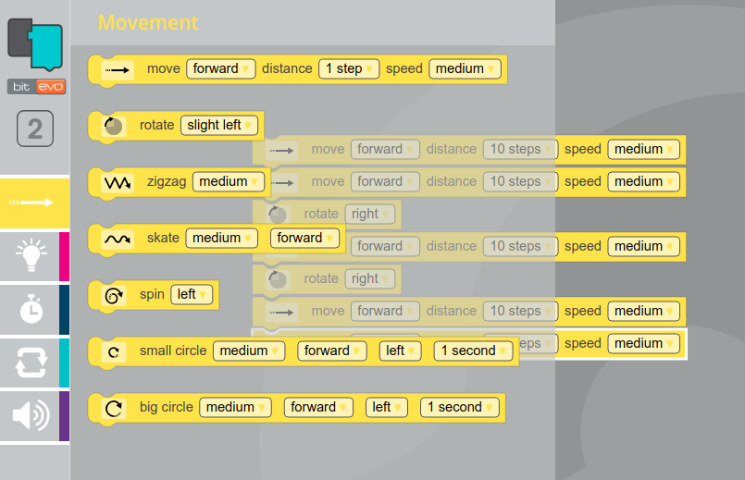

Day 4 (Thursday)

Supplies
- Tablets and Evo’s for each kid  - Foam marshmallows for road for each kid | - Name tags from Day 1  - Demo Supplies:  - Circuit Playground Express with “Magic Wand”  - Laptop to show code for “Magic Wand”

Goals for Day 4 (Thursday)
- Program the Evo to drive on its own using its color and proximity sensors
- Program the Evo to have different behavior depending on the “traffic rules” at the time
- Create your own program to make the Evo do whatever you want!

Schedule for Day 4 (Thursday)
Start Time | Est. Time | Description
8:45 | 25 | Registration
9:10 | 5 | Review Yesterday + Questions?
9:15 | 5 | Demo: “Magic Wand” on Circuit Playground Express  - Show the MakeCode and Javascript for “Magic Wand” on laptop  - This is what you’ll learn at the next level camp!
9:20 | 10 | Discuss Driver-Less Cars [social, auditory]  What kind of sensors do they need? How many different scenarios can you think of (ex: pedestrian walks across street, other car veers into lane, construction on road, rainy)?
9:30 | 30 | Evo Driver’s Ed: Wavy Way [tactile, visual, code]  Program your Evo to navigate a wavy road using the sensors  STORY: Cody using machine vision to automate chip manufacturing  Extra Credit = Evo at higher speed, add obstacles  * Self Driving badge for all
10:00 | 30 | Snack  Make a driver-less car on a road  * Most Creative Snack badge
10:30 | 60 | Evo Driver’s Ed: Traffic Trouble [tactile, visual, code]  Program your Evo to navigate a wavy road that has traffic rules (ex: stop on red)  Extra Credit = change the road, draw new traffic rules  * Traffic badge
11:30 | 30 | Free Style Programming [creative]  Do whatever you want! Extra ideas will be included in the packet. Can be done on your own or in a group
12:00 |  | GO HOME

Driver’s Ed: Wavy Way
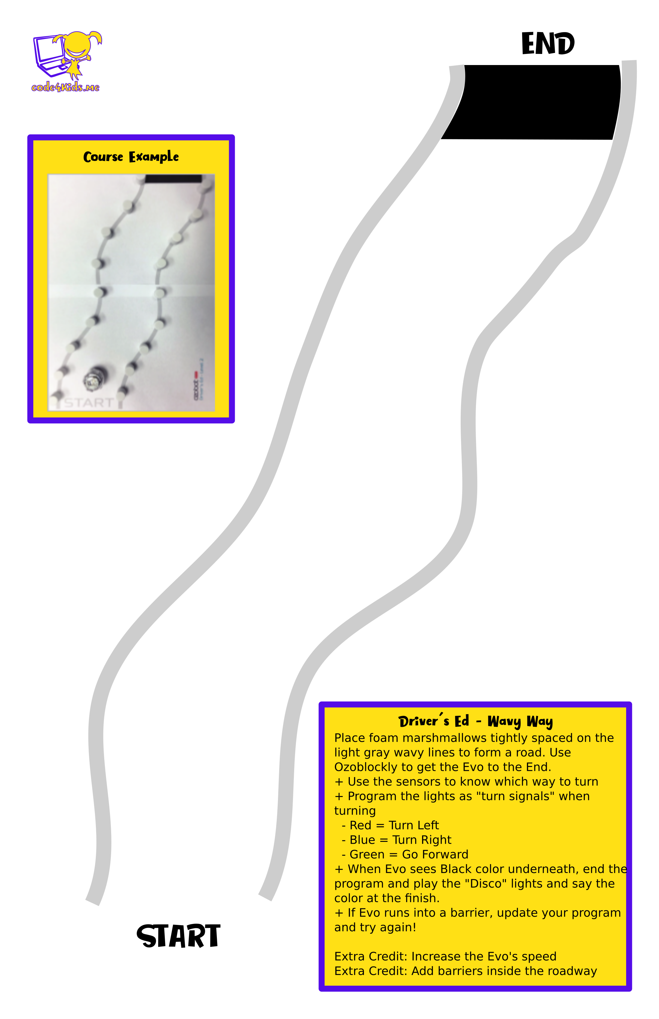

Drivers Ed: Wavy Way Solution
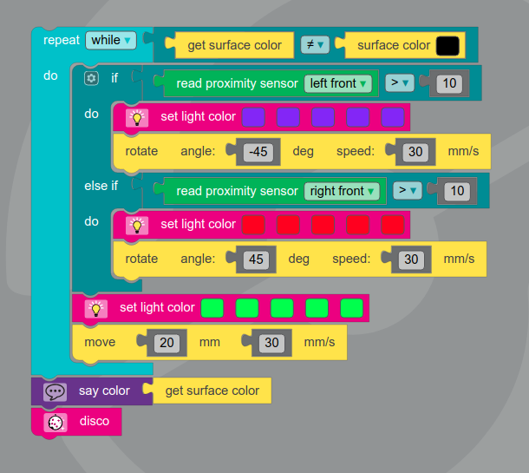

Driver’s Ed: Traffic Trouble
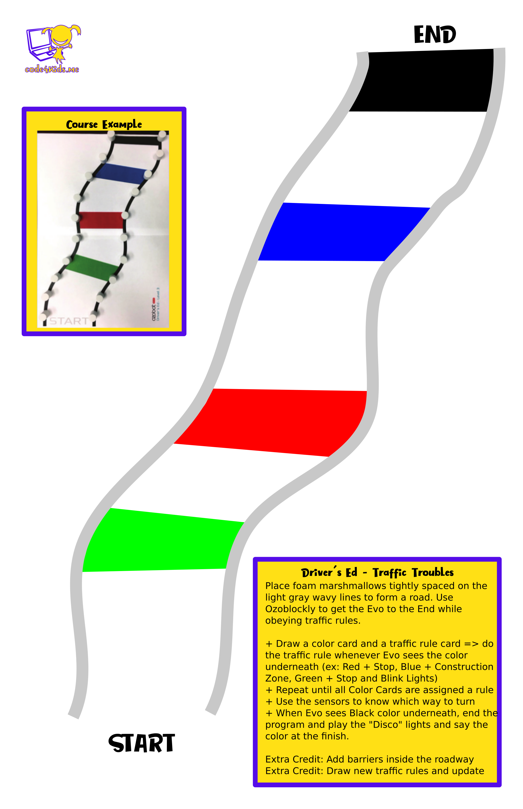

Driver’s Ed: Traffic Trouble Solution
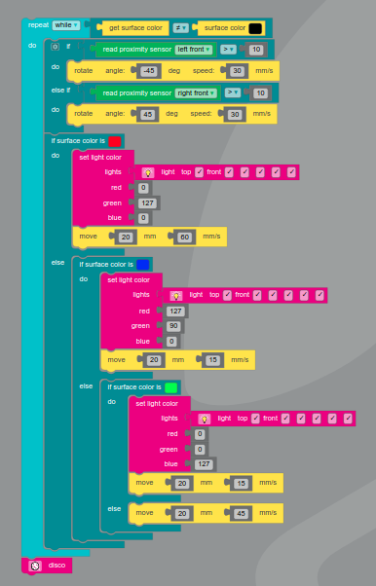

Driver’s Ed: Traffic Trouble – Cards


